COLLEGE OF COMPUTING & INFORMATICS

UNIVERSITI TENAGA NASIONAL

UNITEN EXECUTIVE EDUCATION PROGRAMME MANAGEMENT SYSTEM

NISHANTHINI A/P JEGABADUR

IS0103749

BACHELOR OF INFORMATION TECHNOLOGY (HONS)

INFORMATION SYSTEMS

SPECIAL SEMESTER 2019/2020

UNITEN Executive Education Programme Management System

by

NISHANTHINI A/P JEGABADUR

Project Supervisor: MDM RINA BTE. MD. ANWAR, TS.

A REPORT SUBMITTED IN PARTIAL FULFILLMENT OF THE REQUIREMENTS FOR THE BACHELOR OF INFROMATION TECHNOLOGY (INFORMATION SYSTEMS), COLLEGE OF COMPUTING & INFORMATICS

UNIVERSITI TENAGA NASIONAL

2020

**DECLARATION**

I hereby declare that this report, submitted to Universiti Tenaga Nasional as a partial fulfillment of the requirements for the Bachelor of Information Technology (Information Systems) has not been submitted as an exercise for a degree at any other university. I also certify that the work described here is entirely my own except for excerpts and summaries whose sources are appropriately cited in the references.

This report may be made available within the university library and may be photocopied or loaned to other libraries for the purpose of consultation.

24 July 2020 …………………………………...

NISHANTHINI A/P JEGABADUR

IS0103749

**APPROVAL SHEET**

The thesis entitled:

“Executive Education Programme Management System”

Submitted by:

NISHANTHINI A/P JEGABADUR (IS0103749)

I requirement for the degree of Bachelor of Information Technology (Information Systems), College of Computing & Informatics has been accepted.

Supervisor: MDM RINA BTE. MD. ANWAR, TS.

Signature: ……………………………

Date: 24th June 2020

**ACKNOWLEDGEMENT**

Primarily, I wish to express my sincere gratitude to my advisor Mdm Rina Bte. Md. Anwar, Ts. for continuously supporting and guiding me in completing my final year project successfully. In spite of being in MCO, she was there to constantly guide as well as help me in every way possible throughout my Project 1. In addition, I would like to thank my examiner, Dr Rosnafisah Bte. Sulaiman who believed in me by letting me to do this project and helped me to improvise my project. Without both of their advice and encouragement it would have been harder for me to complete this project.

Besides, a special thanks is a must for my family members for supporting me emotionally and spiritually which encouraged to not giving up on anything easily. Not forgetting my friends who constantly encouraged me to do better and guided me in this journey.

Last but not the least, I would like to take this opportunity to thank those who was there for me either directly or indirectly in completing my final year project entitled ‘Executive Education Programme Management System’.

**EXECUTIVE SUMMARY**

UNITEN Executive Education Programme Management System is a web-based application system which is specially designed for the Business Development Department (BDD) of UNITEN who is currently using manual method for the registration of users into short courses. This application is mainly for the users who are interested in short or special courses and to make the whole process efficient for the staffs.

Managing executive education programmes without the aid of an automation system will take a longer time because there are so many tasks involved in it which may slower the process. This manual method can cause problem to the management and also to the users because managing too many documents manually is difficult. Even though there is a website to provide details of the programs, they do not have a complete system where all the works can be done in a platform.

Therefore, a complete system is need to be developed to manage the programmes easily and efficiently. The objectives to develop this system is to allow users to register themselves for the courses, allow the users to make payment through online, generate receipt and sales report and send e-certificate to the users after the program completion. The proposed system will surely save staffs’ time and also shorten the waiting time of customers.

The software development methodology that have been used to develop the system is waterfall model. Waterfall model is chosen because it is a straightforward process and a phase will begin only after the phase before that is completed. Therefore the phases cannot be overlapped. Every phase of Waterfall model will be able to start and finish within the fixed deadline because they follow a timeline. At the end of each phase, a review takes place to determine if the project is on the right path and whether or not to continue or discard the project. [1]

In conclusion, the proposed system will be a complete system to manage the courses and users effectively and efficiently. Even there are similar systems like this it will be undoubtedly a new experience for BDD as they get to do their work differently and the users will get an opportunity to explore new system. This is because the system is new for the department and its current users.

**TABLE OF CONTENT**

**DECLARATION i**

**APPROVAL SHEET ii**

**ACKNOWLEDGEMENT iii**

**EXECUTIVE SUMMARY iv**

**TABLE OF CONTENT v**

**LIST OF TABLES vii**

**LIST OF FIGURES viii**

CHAPTER 1 INTRODUCTION

1.0 Overview 1

1.1 Background 2

1.2 Problem Statement 3

1.3 Objectives 4

1.4 Scope 5

1.5 Project Timeline 6

1.6 Conclusion 7

CHAPTER 2 ANALYSIS & SYSTEM REQUIREMENTS

2.0 Overview 8

2.1 What is Executive Education Programme Management System? 9

2.2 Review of System 10

2.2.1 Review of Current System 10

2.2.2 Review of Similar Systems 11

2.3 Comparison between Similar Systems 15

2.4 Software Development Methodology 16

2.5 Requirement Gathering Techniques 19

2.5.1 Interview 19

2.6 Tools and Technology 23

2.7 Conclusion 24

CHAPTER 3 ANALYSIS AND SYSTEM REQUIRMENTS

3.0 Overview 25

3.1 Context Diagram 26

3.2 Data Flow Diagram (DFD) Level 0 27

3.3 Entity Relationship Diagram (ERD) 28

3.4 Use Case Diagram 29

3.5 Data Dictionary 30

3.6 Navigation Diagram 34

3.7 System Interface Layout 36

3.7.1 User’s Interface 36

3.7.2 Admin’s Interface 41

3.7.3 Instructor’s Interface 45

3.8 Conclusion 49

4.0 Conclusion 50

References 51

**LIST OF TABLES**

Table No. Page

Table 1.1 Gantt Chart 6

Table 2.1 Similar System Comparison Table 15

Table 2.2 List of Hardware and Software Requirements 23

Table 3.1 User’s Table 30

Table 3.2 Admin Table 30

Table 3.3 Instructor’s Table 31

Table 3.4 Course Table 31

Table 3.5 Enquiry Table 32

Table 3.6 Payment Table 32

Table 3.7 Invoice Table 33

**LIST OF FIGURES**

Figure No. Page

Figure 2.1: Online enquiry form of special programmes 10

Figure 2.2 Homepage of Iverson 11

Figure 2.3 Program added to cart in Iverson 12

Figure 2.4 Homepage of Coursera 12

Figure 2.5 Registration page of Coursera 13

Figure 2.6 Homepage of MIM system 13

Figure 2.7 Course details interface 14

Figure 2.8 Waterfall Model 16

Figure 3.1 Context Diagram 26

Figure 3.2 Data Flow Diagram (DFD) Level 0 27

Figure 3.3 Entity Relationship Diagram (ERD) 28

Figure 3.4 Use Case Diagram 29

Figure 3.5 Navigation Diagram of User 34

Figure 3.6 Navigation Diagram of Admin 35

Figure 3.7 Navigation Diagram of Instructor 35

Figure 3.8: Homepage 36

Figure 3.9: Enquiry form 36

Figure 3.10: Course List Page 37

Figure 3.11: Course Details Page 37

Figure 3.12: Shopping Cart Page 38

Figure 3.13: User Register Page 38

Figure 3.14 User Signin Page 39

Figure 3.15 Checkout Page 39

Figure 3.16 Payment Successful Page 40

Figure 3.17 Admin Login Page 41

Figure 3.18 Admin Dashboard 41

Figure 3.19 Enquiry Management Page of Admin 42

Figure 3.20 Course Approval Page 42

Figure 3.21 Invoice Approval Page 43

Figure 3.22 Instructors’ List Page 43

Figure 3.23 Form to add instructors 44

Figure 3.24 Logout Prompt of Admin Page 44

Figure 3.25 Instructor Login Page 45

Figure 3.26 Instructor Dashboard 45

Figure 3.27 Approved Course List Page 46

Figure 3.28 Update Course Form 46

Figure 3.29 Add Course Form 47

Figure 3.30 Enquiry Management Page of Instructor 47

Figure 3.31 Users’ Information Page 48

Figure 3.32 Logout Prompt of Instructor Page 48

**CHAPTER 1**

**INTRODUCTION**

**1.0 OVERVIEW**

Chapter 1 consists of background of the problem, problem statement, objective, scope and project timeline. This chapter describes the project details thoroughly.

**1.1 BACKGROUND**

Universiti Tenaga Nasional (UNITEN) was established in 1999 and is one of the first private universities in Malaysia. It is wholly owned by the public listed Tenaga Nasional Berhad (TNB) UNITEN has various departments functioning under it, contributing towards the success of the university in every aspects and Business Development Department (BDD) is one of them. BDD offer and manage professional services to create long-term value for the university from its customers, markets, and relationships with the local and global community. [2] It also provides consultative help in the products, services and operation of UNITEN. This department is handling the rental facilities, professional services and special programs held by UNITEN. Under the special programs, executive education programs are designed to enhance technical skills in engineering, management and computing, leadership skills, and build foundation in general management. Example of programs they are offering is energy management, big data & analytics, computing & IT solutions and more. These programs are considered as special programs because these programs are offered to public and corporate clients to enhance their knowledge and skills in a specific or new field.

With the current website, the short courses are listed in the website which can be viewed by the users. The users can see the details and inquire about the courses. The staffs have to call back or e-mail the users who have inquired about the courses to give further details on it and will manually register the users into the courses. Hence, a web-based UNITEN Executive Education Programme Management system should be developed to ease the whole process and making it beneficial for all three parties which are the users, staffs and also the university. This automated system can perform several activities such as register for the courses, pay for the courses through online, provide e-certificate for the users after their course completion and allow users to view course details and enquire about that. Moreover, keying-in the participant names manually into a course may cause human error anytime so, the development of the system can help to overcome that too. In a nutshell, this system will improve the quality of the process of managing executive programmes of UNITEN in a more systematic and functional way.

**1.2 PROBLEM STATEMENT**

The BDD do have a website where people can view the programs or short courses offered by UNITEN and enquire about the programs but the users cannot register themselves into the programs or buy the modules online. After receiving the inquiry, the department staffs have to call back the users one by one to note down their information and manually register them in the programs. Sometimes, the customers directly call the in-charge person to get themselves registered in course. Therefore, they have to manage too many documents at a time manually. Due to this they may face problems caused by human errors such as registering an user in a program that already have enough number of participants, users who have not paid can be marked as already paid, keying-in the users name in a wrong program and more. This can be problematic to the users as well as the management.

Other than that, people nowadays prefer online payment than manual payment because it is considered to be not safe keeping large amount of money with them. But this existing system do not have the advanced technique in it and user have pay by cash or cheque at the UCC payment counter or instructed to transfer the money to a particular account which is not safe. If there is any error in recording the transactions, this may cause trust issues between the users and management in future if any problem occurs.

Most importantly, they do not have a complete system where all the activities can be done in a platform. Their current system is incomplete because users can only view the course details and inquire about it. The staffs have to check all the inquiries and get back to the users one by one which can take longer time. The users also have to wait for the staffs to call them back which may take longer period than expected by them. Sometimes, the users do not even use that online enquiry form instead, they directly call person in-charge to get details of the courses. This makes the whole current process inefficient.

**1.3 OBJECTIVES**

The main objective of developing UNITEN Executive Education Programme Management system is to benefit the users by designing a system which can help them to enrol in the short courses provided by UNITEN easily and efficiently. This system will definitely ease the work of users and staffs. Besides that, to save the staffs’ time and also shorten the waiting time of the users who in previous should wait for the staffs’ call to enrol in courses. The system developed will be a complete web based system with the following functions to manage executive programmes organised by UNITEN. Other than this, the functionalities of the system are to:

1. provide course details
2. allow users to register for the courses
3. allow online payment
4. produce receipt and generate sales report
5. prepare and send e-certificate once after the course completion

**1.4 SCOPE**

The project scope can be categorized into two that are user scope and system scope. User’s scope is to determine the users who have the access to use the system and their level of authorization. While, system scope is to specify the function of the system.

**1.4.1 User Scope**

There will be three types of users who can access the system:

1. Admin

The system admins are allowed to access to manage all the information. Admin can approve the programs, reply the enquiries, view user information, add instructors and update the users’ payment status and approve invoice.

1. Individuals, students and corporate customers from other companies

Users can view program details and enquire about it. They also can register themselves in the program they like and make payment through online.

1. Instructors

Instructors are the people who is going to educate the courses to users. They are in charge of the programs therefore, they can add programs and edit and update the existing programs. They also have access to the users’ information who registers.

**1.4.2 System Scope**

This system will be equipped with the following function:

a) The system will allow users to view course details and enquire about the program

b) The system will allow users to register themselves in the courses

1. The system will allow users to make payment through online
2. The system will be able to send e-certificate to the users after their completion
3. The system will be able to produce receipt or invoice for the users

**1.5 PROJECT TIMELINE**

The project timeline for this is project is explained in the form of Gantt chart and shown in Table 1.1

**Table 1.1 Project Management Gantt Chart**

|  |  |  |  |  |  |  |  |  |  |  |  |  |  |  |  |  |
| --- | --- | --- | --- | --- | --- | --- | --- | --- | --- | --- | --- | --- | --- | --- | --- | --- |
| **Task** | **Week** | | | | | | | | | | | | | | | |
| **1** | **2** | **3** | **4** | **5** | **6** | **7** | **8** | **9** | **10** | **11** | **12** | **13** | **14** | **15** | **16** |
| Project Supervisor and Title |  |  |  |  |  |  |  |  |  |  |  |  |  |  |  |  |
| Project Proposal Submission |  |  |  |  |  |  |  |  |  |  |  |  |  |  |  |  |
| Study System Requirements |  |  |  |  |  |  |  |  |  |  |  |  |  |  |  |  |
| Executive Summary  Draft |  |  |  |  |  |  |  |  |  |  |  |  |  |  |  |  |
| Chapter 1 – Introduction  Draft |  |  |  |  |  |  |  |  |  |  |  |  |  |  |  |  |
| Chapter 2 – Analysis & System Requirement  Draft |  |  |  |  |  |  |  |  |  |  |  |  |  |  |  |  |
| Executive Summary, Chapter 1 and Chapter 2 Draft Submission |  |  |  |  |  |  |  |  |  |  |  |  |  |  |  |  |
| Milestone 1 & 2 Submission |  |  |  |  |  |  |  |  |  |  |  |  |  |  |  |  |
| Chapter 3 – Design  Draft |  |  |  |  |  |  |  |  |  |  |  |  |  |  |  |  |
| Chapter 3 Draft  Submission |  |  |  |  |  |  |  |  |  |  |  |  |  |  |  |  |
| Poster Design |  |  |  |  |  |  |  |  |  |  |  |  |  |  |  |  |
| Poster Presentation |  |  |  |  |  |  |  |  |  |  |  |  |  |  |  |  |
| Milestone 3 – Final  Report Submission |  |  |  |  |  |  |  |  |  |  |  |  |  |  |  |  |
| Logbook Submission |  |  |  |  |  |  |  |  |  |  |  |  |  |  |  |  |

**1.6 CONCLUSION**

In conclusion, this chapter explains about the background of the project, the problems faced by the organization, the objectives of the proposed system, the project scope and the timeline to develop the whole system. We can hope that the executive education programs can be managed easily through the development of the proposed system.

**CHAPTER 2**

**ANALYSIS AND SYSTEM REQUIREMENTS**

**2.0 Overview**

Chapter 2 define the executive education programme management, review similar systems like proposed system and compare it. It will also discuss about the software development methodology, requirement gathering technique and the tools and technology used.

**2.1 What is Executive Education Programme Management?**

Executive Education Programme Management System is a computer-based system that manages the short courses organised by the university, improves the performance of the organization. There are some courses that could not be included in our study program due to limited credit hours or some courses we want to learn to gain extra knowledge about a specific field; these are the courses we can find in the executive programme management. In most of the universities they do not have a system for this particular program because they think they can handle in manually but UNITEN wants to develop a system for this because they want to attract more users towards them by offering more programmes and promoting it online. And they also consider that handling all this manually can burden the management and staffs more. So, this system will act as a mediator for the user and the staffs or management. They system will give better experience for the users by making it easier for them to register for the courses and pay through online directly without waiting for the staffs to call them back. And for the staffs, they do not have to get back to all the users one by one and they can focus on other things instead of that.

**2.2 REVIEW OF SYSTEM**

**2.2.1 Review of current system**

The current method that is being used by the UNITEN BDD to register for the special programmes is manual where the users will view the program details and inquire about it through the website they already have which attached to the UNITEN official website or UNITEN Student Hub. Afterwards, the processes will be done manually starting from the staff notice the inquiry and call back or e-mail each one of them to give further explanations about the programs and register their names in the programs they wanted to participate in. If users want to buy the online module and do not want to attend the program they have to transfer the required money to UNITEN account and get the module through e-mail. After the program completion, the participants will receive their certificates by hand or mail. In overall, this method is an inconvenient and inefficient method because it takes longer time to call back each one of them and the users have to wait for the call from the staff or they have to call the management if it takes longer time than expected by them. By registering manually, the data could get lost, destroyed or ripped easily if it is not protected well. This can cause problems not only for the users but also for the management. As we all know, user information is vital and it is hard to be maintained nowadays because it is large. And also with the payment, paying through cash, cheque or fund transfer is not preferable nowadays.

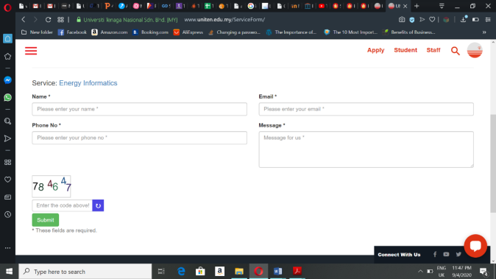

**Figure 2.1: Online enquiry form of special programmes**

**2.2.2 Review of Similar System**

There are some systems which has been developed to ease the process of managing executive education programmes (short courses). These systems are mainly found in websites. Each organisation has been very particular about the systems’ functions and has its own unique feature. The comparison is made based on overall features of each system.

1. Iverson (URL: https://www.iverson.com.my)

Iverson is an organisation that provides high-quality IT training solutions to corporate customers, meeting their learning needs and helping them achieve their training objectives. Their training courses are created to meet the needs of corporate customers ranging from small, medium to large organisations. Iverson promote their shout courses through their website. This website allows their customer to view their program details and enquire about them. After choosing the program they want register for the customers have to fill in their details and card information or online banking information to pay for the courses through online. It also provides e-certificate for users after the program completion. Not just that, Iverson also provides online modules for those who do not want to attend the live program.

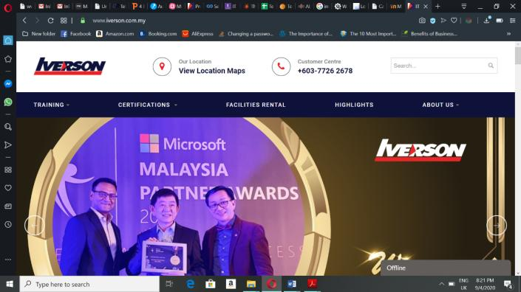

**Figure 2.2 Homepage of Iverson**

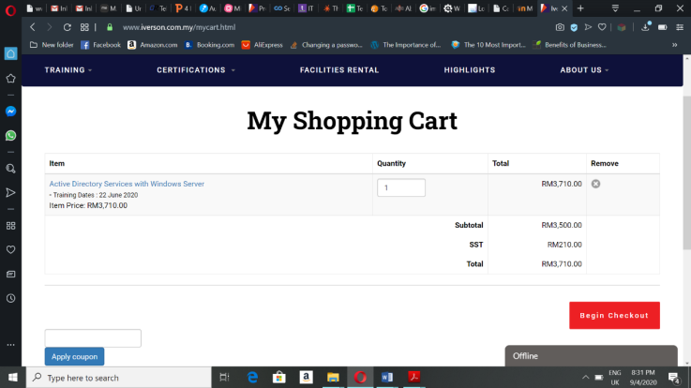

**Figure 2.3 Program added to cart in Iverson**

2. Coursera (URL: https://www.coursera.org)

Coursera is an American online learning platform that offers massive open online courses, specializations and degrees. It allows its users to view courses from various universities and organizations in a variety of subjects. The users can register themselves, enrol in courses and pay for the courses through online payment. It also provide online certificate after completion of the program.



**Figure 2.4 Homepage of Coursera**

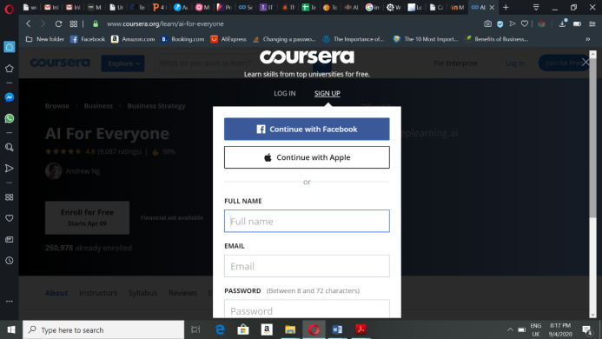

**Figure 2.5 Registration page of Coursera**

3. Malaysian Institute of Management (MIM) (URL: https://www.mim.org.my)

MIM is a leading membership-based organisation which, for over half a century, has served as the definitive voice of leadership and management across the country. This organisation offers several short courses which provide professional certification to help people achieve professional career in future. This system let users to view the course details and enquiry about the courses. Users can add the courses to the cart after registering themselves and pay through online. The system also indicates the time left for the course begin and if the course has passed.

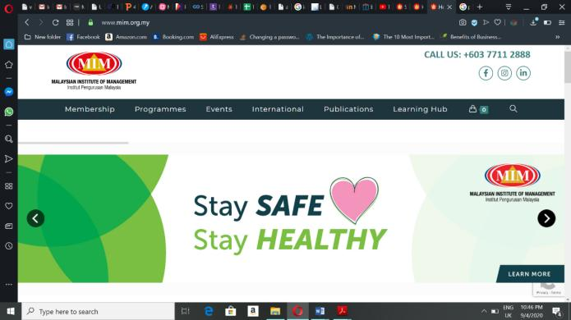

**Figure 2.6 Homepage of MIM system**

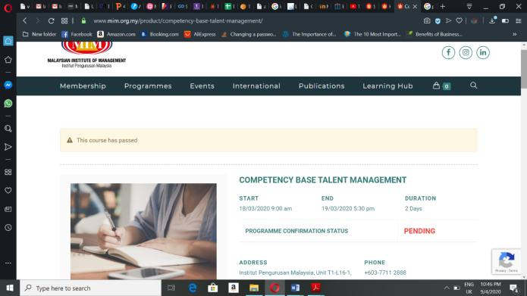

**Figure 2.7 Course details interface**

**2.3 COMPARISON BETWEEN SIMILAR SYSTEMS**

The table below shows comparison between the proposed systems, UNITEN Executive Programme Management System with other 2 similar system.

|  |  |  |  |  |  |
| --- | --- | --- | --- | --- | --- |
| No. | Similar  Systems    Features | Iverson | Coursera | MIM system | Proposed System |
| 1. | Choose a course and view course details |  |  |  |  |
| 2. | Enquire about the courses |  |  |  |  |
| 3. | Registration |  |  |  |  |
| 4. | Search and filter courses |  |  |  |  |
| 5. | Payment through online |  |  |  |  |
| 6. | Provide e-certificate |  |  |  |  |
| 7. | Provide face-to-face programs |  |  |  |  |
| 8. | Provide online programs |  |  |  |  |

**Table 2.1 Similar System Comparison Table**

**2.4 SOFTWARE DEVELOPMENT METHODOLOGY**

Software Development Methodology is a framework that is used to structure, plan and control the process of developing an information system.[3] The methodology plays an important role in the developing a system or project since it determines the success or failure of a software project. The methodology used for this project development is Waterfall model. The waterfall model is a breakdown of project activities into linear [sequential](https://en.wikipedia.org/wiki/Sequence) phases, where each phase depends on the deliverables of the previous one and corresponds to a specialisation of tasks.[4] The waterfall model has been chosen because it goes well with almost all the systems.

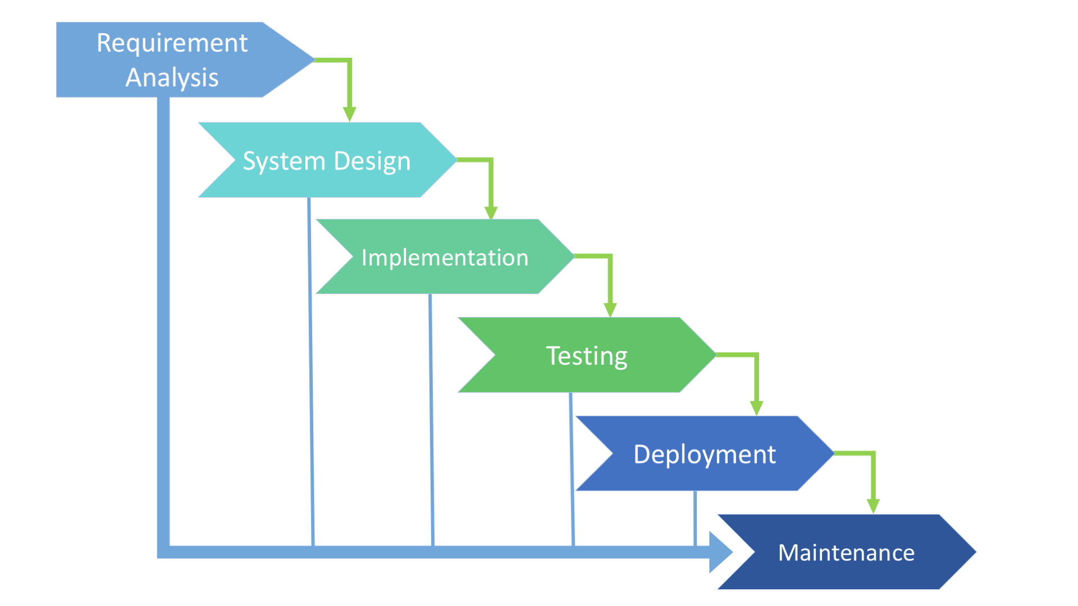

**Figure 2.8 Waterfall Model**

There are 6 phases involved in the waterfall model which are requirement analysis, system design, implementation, testing, deployment and maintenance. How each of these phases are implemented for the proposed system is explained further below:

* Requirement Analysis

This is the first phase of waterfall model. In this phase, activities such as project initiation and requirement gathering will take place. During project initiation, the problem statement and objectives of the project are identified which can show what is the main purpose for the development of the proposed system. After that, all the relevant requirements of the project are collected and analysed to make sure it can be used to satisfy the end-user requirements. Analysed requirements then documented in a specification document and a feasibility analysis is done to check if these requirements are valid. Limitations and restrictions such as time and budget are also examined so that it does not affect the development process of the project in the future.

* System Design

The second phase of this methodology is system design. For the proposed system, the system design phase will take place in Chapter 3. Upon identifying and understanding the requirements that has been gathered from the first phase, the developer will use the ideas to come up with the system design and design the interface of the proposed system. The deliverable for Chapter 3 will be Class Diagrams, Data Dictionary, Navigation Diagram and System Interface Layout.

* Implementation

The implementation stage is where the actual code is written by the programmers to turn the design phase into a workable system. Initially, the proposed system will be developed in many small modules, after which these modules are combined together to work as complete system. The development of UNITEN Executive Education Programme Management begins with the development of system interfaces and then connected to database and followed by the function of the system. This phase has been done in the Project 2.

* Testing

In testing phase, each developed system function in the earlier phase will be tested individually and the integration testing will begin once all functions of the system work as intended to ensure they are error-free and meet the user requirements in the first step. This project will be tested by the lecturers or staff of UNITEN where they will be provided with a checklist of requirements to make sure they meet with requirements that have been gathered in analysis phase.

* Deployment

The deployment phase will take place once the integration testing is successfully done. The system will be deployed into the user environment in order to the test its performance and report if there is any bugs or error occur in the system. The deployed system becomes available for the end-users after the BDD installed the system.

* Maintenance

The final phase of waterfall model is maintenance where the system is technically repaired and improved. Even though the system is fully tested and deployed, a new system often need ongoing maintenance because problems may still continue to arise. Therefore, the proposed system will undergo maintenance regularly. Maintenance is essential for a system as it will make sure that the system is up-to-date and operating efficiently without causing technical issues.

**2.5 REQUIREMENTS GATHERING TECHNIQUE**

Interviews considered as one of the primary sources of requirements. Therefore, one-to-one interview is used for gathering requirements to develop the system. There are 2 people who have been interviewed to gather information. One of them is the staff who is working in the business development department and the other one is a short interview with the user who wanted to participate in the courses but could not. Before interviewing these 2 person there was a meeting held with the Head of Business Development Department, Dr Rosnafisah who needed this system for the department. This meeting was held for clear understanding of what are the requirements of the head of department. The HOD stated the functions needed to be in the system, that are users able to enrol themselves in the courses, make payment through online, the system must be able provide e-certificate, more than one program can be added to cart and the system able to produce and send receipt for the users.

**2.5.1 Interview**

The first interviewee, Puan Harizatul Akma who has been working with UNITEN for almost 10 years and with BDD for 4 years now. She is the in-charge person of the all the special programmes which are held by Business Development Department. The questions asked in this interview are:

a) Can Puan brief about the whole of this short course registration process?

Yes, sure. Initially, users submit their enquiry about the course through provided online form in the website and the staffs will get back to them through email or phone call to provide them brochures or more details of the courses. But nowadays, mostly users directly call the in-charge person instead of using the online enquiry form because they think it takes longer time to get back reply. The payment is made with either cash or cheque at UCC payment counter or through electronic bank transfer if they could not make it to UNITEN. She further goes on explaining the process which is already stated in review of current system.

b) Which type of clients mostly participates in the programmes? Internal or external clients?

The main clients are mostly external, which consist of participants from other companies, students, individuals and more.

c) How these executive education programmes or short courses are being promoted?

We promote these courses through their social media such as Facebook, email and by brochures, banners, livewire TNB, etc.

d) How are the receipts and sales report produced?

It is based on invoice that BDD have issued to the clients or participants and the process quite long.

e) What are difficulties faced by the staffs and management during this courses registration process?

Now with the current practice, registration is done manually. Head of program have submit all the documents for program registration by using forms so they have to manage too many documents which slower the process. This method is also time consuming as almost everything is done manually even getting approval from the Dean or Director. And if the documents lost it can be problematic for the head of program as everything need to be done again. And with too many papers or forms it is difficult for the executive to manage all the documents in the file.

f) Do you think the current method for registration is satisfying and efficient enough?

No, because it takes a longer time and many problems occur in meanwhile. If the registration can be done in a system registration can be done easily and approval can be accessed from outside the office..

g) How the certificates are given out to the participants?

The certificates are prepared by the BDD staff, based on the name list given to them and later BDD will post the certificated to the participants.

h) If there is system developed for this, how it can solve the problem.

There will be no repetition of work as all the data or information can be extracted from the system. Other than that, there is no need to maintain the record manually, the data can be accessed anywhere and lots of time can saved with this system.

Through this interview, the main problems faced by the department are clearly stated by the Puan Harizatul and helped in identifying the requirements to complete the system. It is also known that a complete system for this process can make it a whole lot better for the department.

The second interviewee is Kumaran who is working in an IT company and former UNITEN student, who wanted to participate in one of the courses but could not make it due to some reasons.

a) Have you ever participated in any the executive education programmes?

No, I have never participated in any of the programmes or courses before but I was very keen on participating in a virtual reality course because I was interested in it.

b) How do you get to know about the course?

I got to know from Facebook while I was his scrolling I happen to know that UNITEN offering short courses and checked on their official website to get more details on it.

c) Then why did not you get yourself registered in the programme you were interested in?

Actually, after reading the course details I contacted the person in-charge because I felt it might take a long time to fill in the enquiry form and get back reply from them. They get my email id and send me brochures and information of the course. After I read it and get to know about the course in detail, I thought of contact back the staffs later but forgotten due to my work pressure. But, if there was a system for the registration I would have easily joined the course because registering manually takes a longer time and I felt it is a longer process.

d) What can be done by the management to make the process more efficient?

In my opinion, having a complete website or system can make it whole lot easier for everyone to register themselves without any difficulties.

Even if it is a short interview, it clearly showed the problems faced by an user from their perspective. Both the staff and user felt that having a complete system to manage the registration and approval process can make the whole process easier than expected. These two interviews helped in gathering the requirements and identifying the functions needed to build the complete system entitled ‘Executive Education Programme Management System’.

**2.6 TOOLS AND TECHNOLOGY**

Choosing the right tool and technology to be used in software development process is essential as it can literally make or break a project. Tools and technology includes all of the requirements needed to develop a system. The requirements can be divided into 2 main categories that are software and hardware. There are some hardware and software that has been used to develop the system. Wamp Server is used to create web application by connecting the database. Programming languages such as HTML, PHP, JavaScript, CSS and MySQL are used to create interface and functions of the system to be efficient.

**Table 2.2 List of Hardware and Software Requirements**

|  |  |
| --- | --- |
| Requirements | Tools |
| Software | 1. Xampp Server  2. Windows 8 and above  3. Programming Language:   * CSS * HTML * PHP * JavaScript * MySQL |
| Hardware | 1. Memory  2. Processor: Intel 3 and above  3. Other required devices |

**2.7 CONCLUSION**

This chapter is discussed about the analysis and requirement of the project which consist of the methodology, technology and tools that will be used to develop the system. Existing similar systems are identified and compared with the proposed system to obtain appropriate functionality in the development of the system. This chapter also discusses about the requirement gathering techniques which have been analysed to collect all the functional and non-functional requirements. The flow of the project is also discussed to ensure the project is on the right path.

**CHAPTER 3**

**DESIGN**

**3.0 Overview**

Chapter 3 focuses on the diagram developed to show the functionalities of the proposed system and its early designs of graphical user interface. This chapter also includes data dictionary and navigation page which navigates the structure of the proposed system.

**3.1 CONTEXT DIAGRAM**

**Figure 3.1** shows the context diagram of UNITEN Executive Education Programme Management System. This diagram revolves around data flow from the system to the entities. There are several input and output from three different entities that are user, admin and instructor to the system.

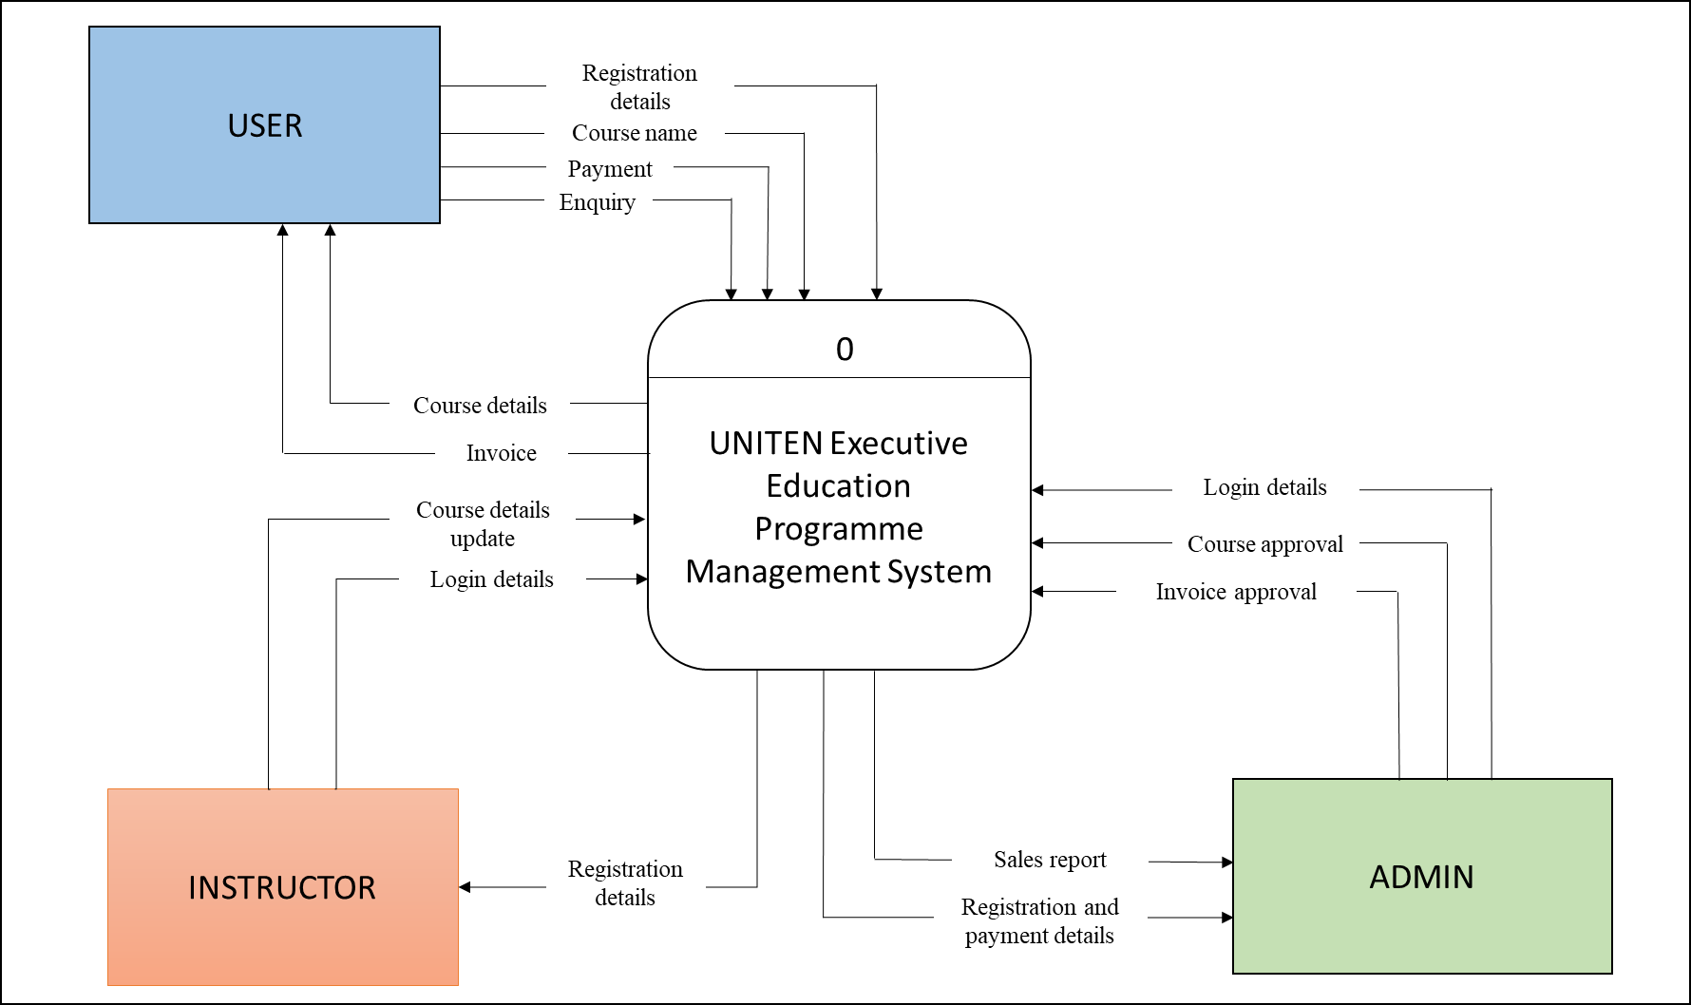

**Figure 3.1 Context Diagram**

**3.2 DATA FLOW DIAGRAM (DFD) LEVEL 0**

**Figure 3.2** shows the Data Flow Diagram of the UNITEN Executive Education Programme Management System. This diagram is an expansion of the context diagram which shows the data flow and process in the system in detail.

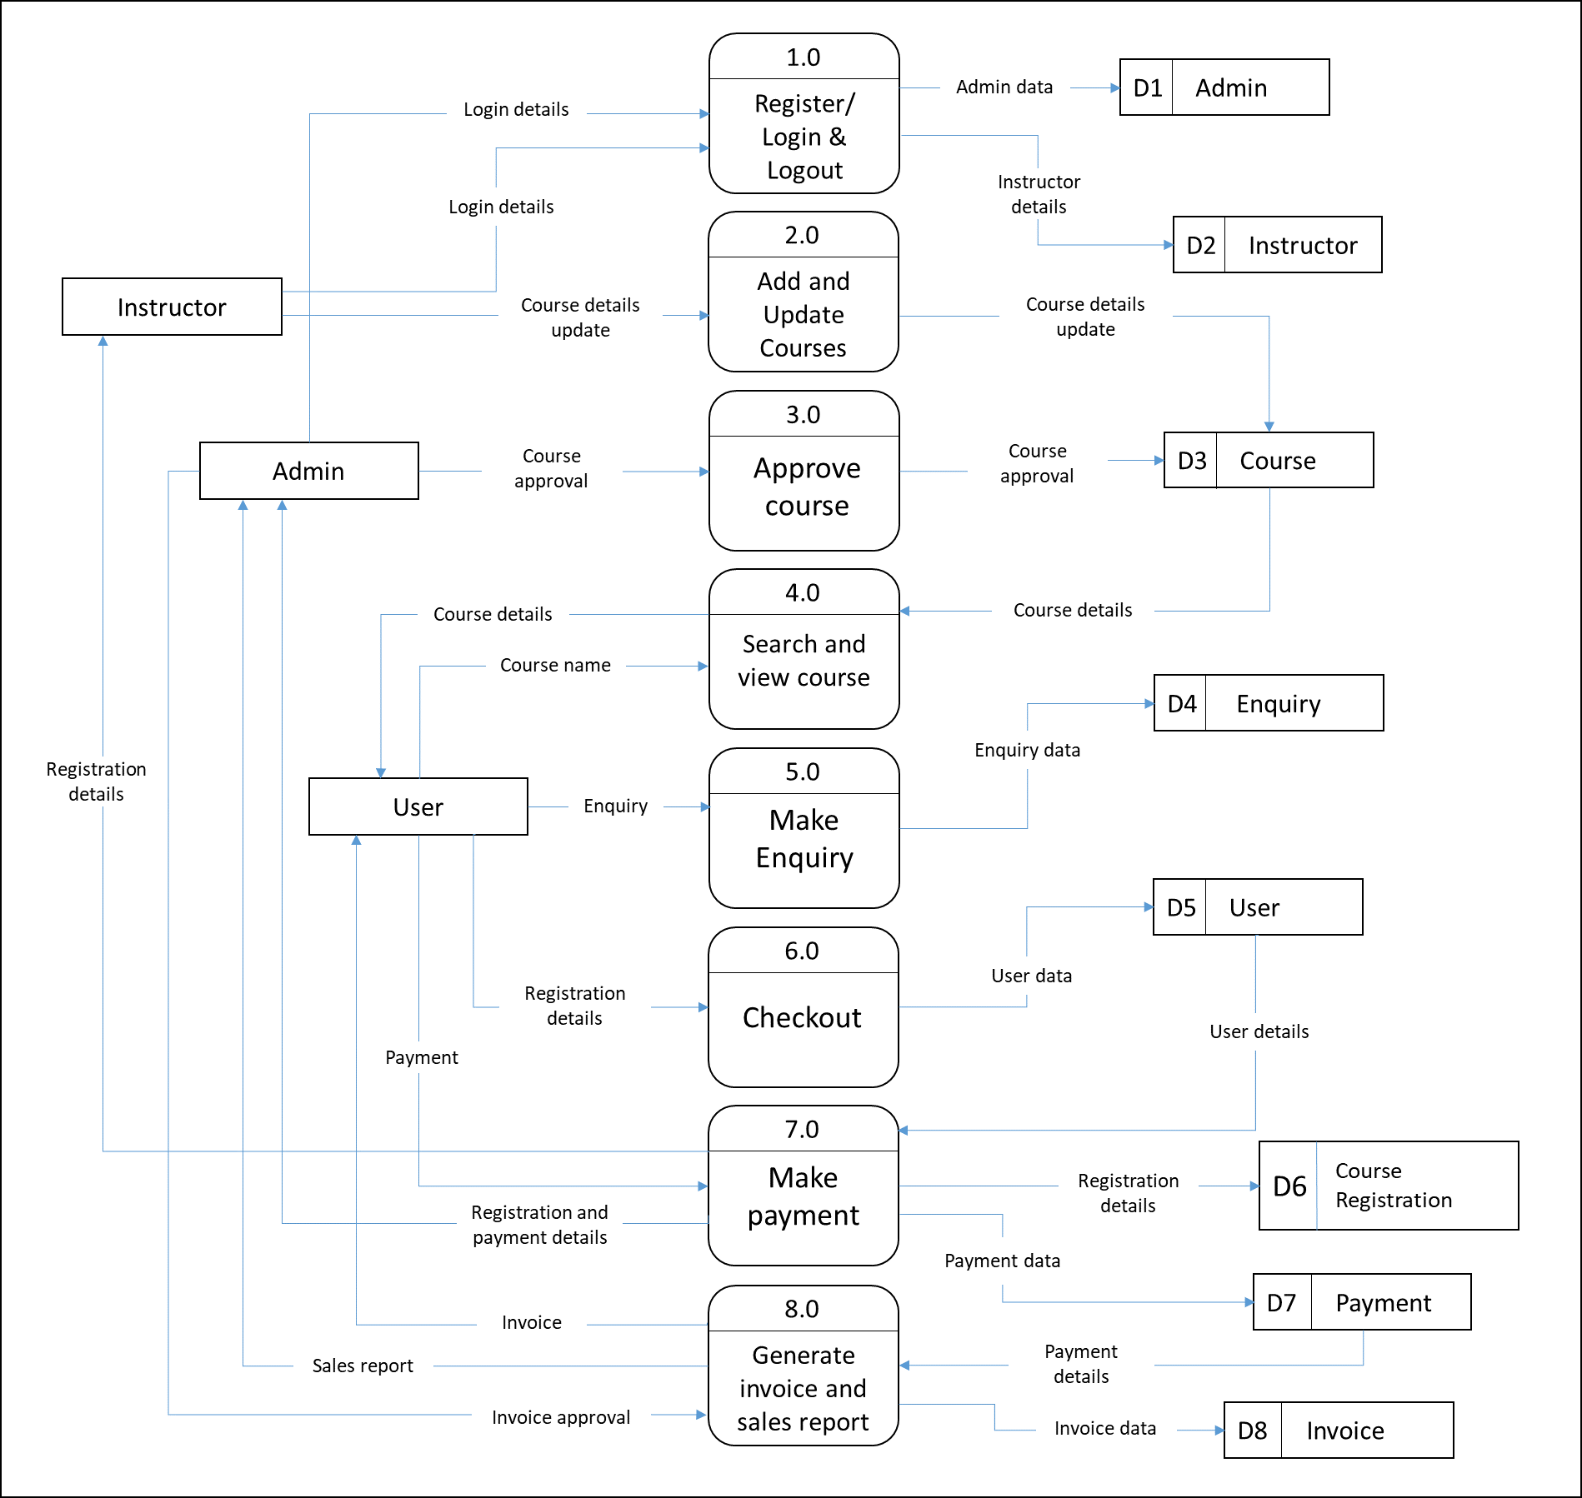

**Figure 3.2 Data Flow Diagram (DFD) Level 0**

**3.3 ENTITY RELATIONSHIP DIAGRAM (ERD)**

**Figure 3.3** shows the Entity Relationship Diagram of UNITEN Executive Education Management System. This diagram shows how the entities in the database are related to each other. There are 7 tables in this system which have their respective attributes.

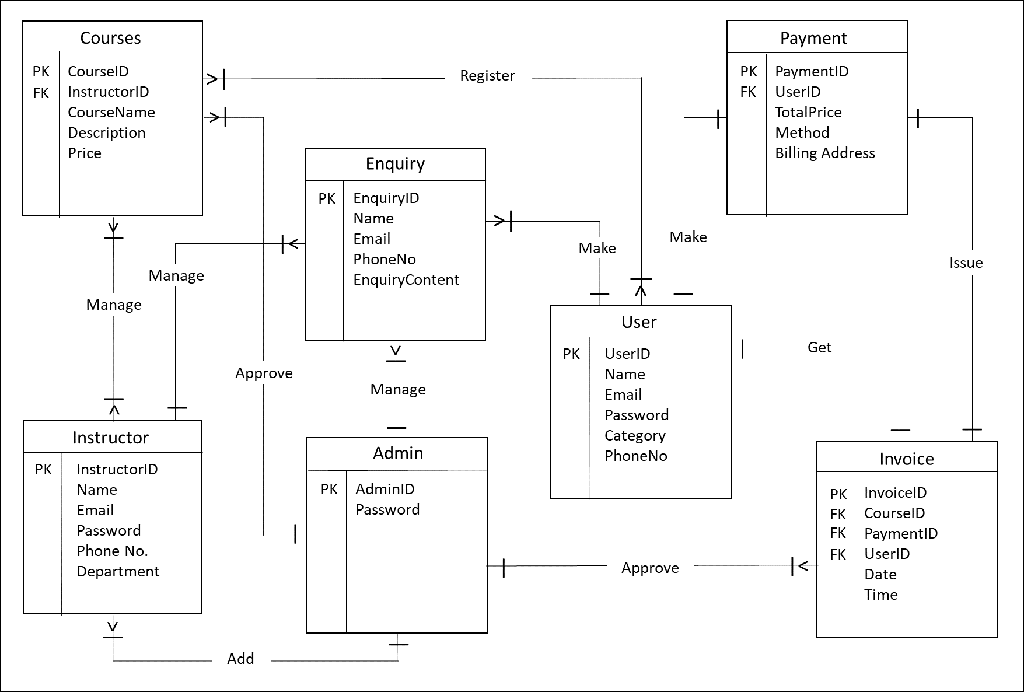

**Figure 3.3 Entity Relationship Diagram (ERD)**

**3.4 USE CASE DIAGRAM**

**Figure 3.4** shows the use case diagram of UNITEN Executive Education Management System. Three actors involved in this system that are the users, admin and instructors. The system have several functions that is also known as features of the system.

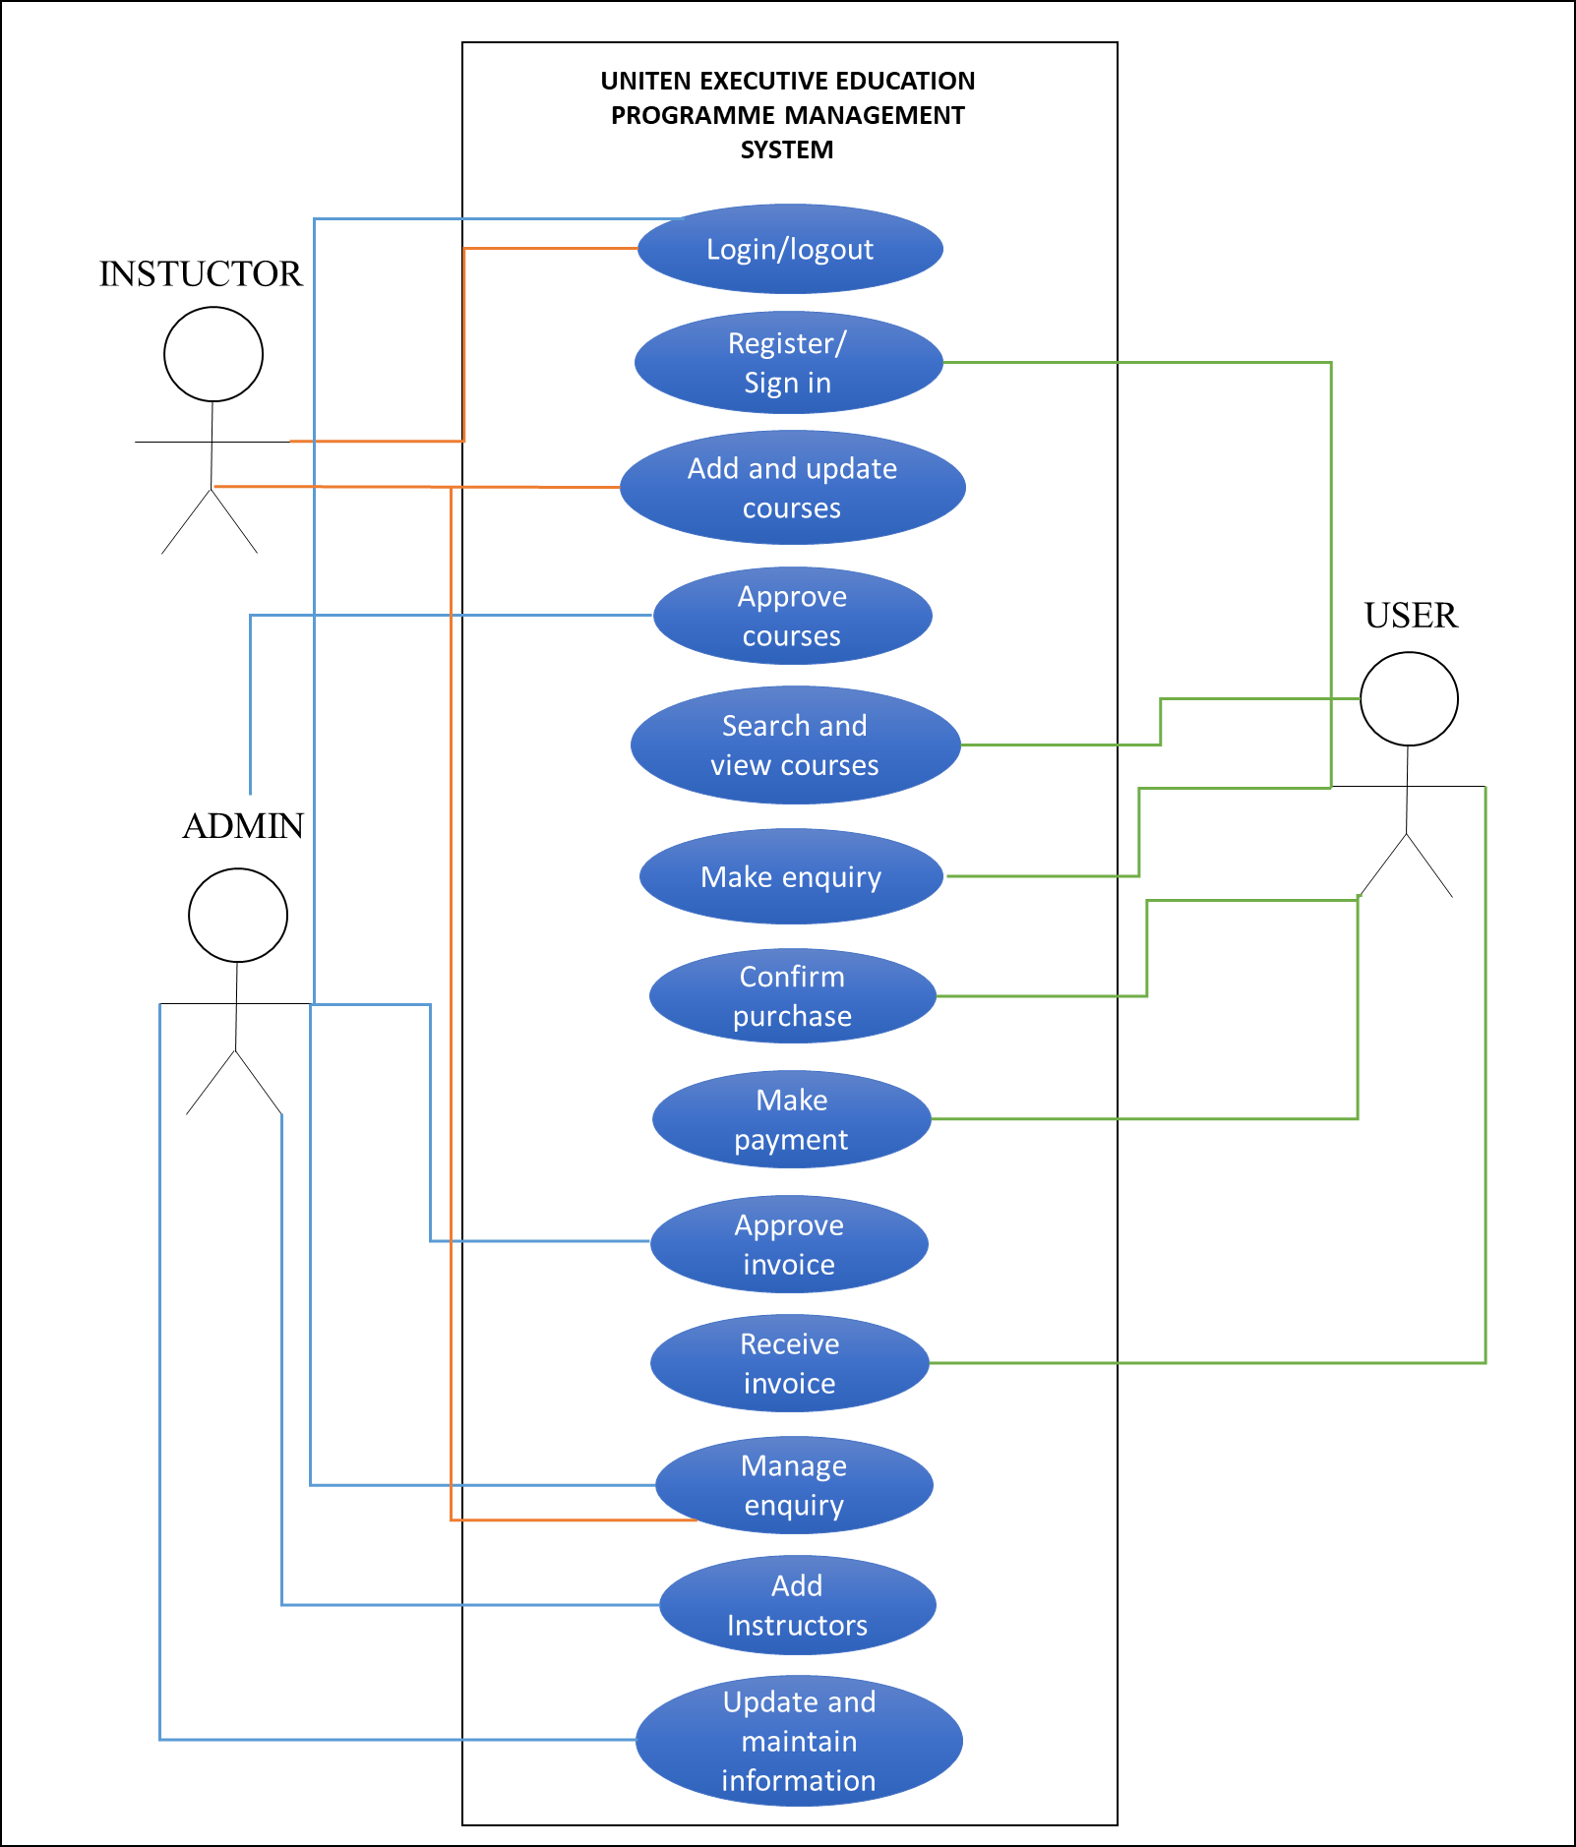

**Figure 3.4 Use Case Diagram**

**3.5 DATA DICTIONARY**

Data dictionary contains information such as structure of the database and table contents such table name with its attributes, description, data type, constraints and data format that has been used for development of UNITEN Executive Programme Management System.

**Table 3.1** shows the user’s table that containing information of users such as user id, name, email, password, mobile number and user category.

**Table 3.1 User’s Table**

|  |  |  |  |  |
| --- | --- | --- | --- | --- |
| **User** | | | | |
| **Attributes** | **Description** | **Type** | **Required** | **PK/FK** |
| User_ID | User ID that uniquely identifies user | Integer(20) | Yes | Primary Key |
| Name | User’s name | Varchar(255) | Yes |  |
| Email | User’s email  address | Varchar(255) | Yes |  |
| Password | User’s password  used to login | Varchar(255) | Yes |  |
| PhoneNo | User’s phone  number | Integer(11) | Yes |  |

**Table 3.2** shows admin’s table that containing login details of admin such as admin id and password.

**Table 3.2 Admin Table**

|  |  |  |  |  |
| --- | --- | --- | --- | --- |
| **Admin** | | | | |
| **Attributes** | **Descriptions** | **Type** | **Required** | **PK/FK** |
| Username | Admin’s unique ID  that identifies admin | Varchar(50) | Yes | Primary  Key |
| Password | Admin’s password | Varchar(20) | Yes |  |

**Table 3.3** shows instructor’s table where it contains the instructor’s id, name, email, mobile number and more.

**Table 3.3 Instructor’s Table**

|  |  |  |  |  |
| --- | --- | --- | --- | --- |
| **Instructor** | | | | |
| **Attributes** | **Description** | **Type** | **Required** | **PK/FK** |
| Instructor_ID | Instructor ID that uniquely identifies user | Integer(10) | Yes | Primary Key |
| Name | Instructor’s name | Varchar(255) | Yes |  |
| Email | Instructor’s email  address | Varchar(255) | Yes |  |
| Password | Instructor’s password  used to login | Varchar(255) | Yes |  |
| Staff_num | Instructor’s staff number | Varchar (12) |  |  |
| PhoneNo | Instructor’s phone  number | Integer(13) | Yes |  |
| Verification_id | Unique verification used to verify instructor’s email | Integer(11) | Yes |  |
| Verification | Instructor’s email verification status | Integer (1) | Yes |  |
| Status | Instructor’s status of account availability | Varchar(45) | No |  |

**Table 3.4** shows course table that containing details of courses such as course id, name, description, course price and instructor name who conducts the course.

**Table 3.4 Course Table**

|  |  |  |  |  |
| --- | --- | --- | --- | --- |
| **Course** | | | | |
| **Attributes** | **Description** | **Type** | **Required** | **PK/FK** |
| Course_ID | Course ID that uniquely identifies course | Integer (11) | Yes | Primary Key |
| Categories_ID | Category that the course belongs to | Integer (11) |  |  |
| CourseName | Course’s name | Varchar(255) | Yes |  |
| Description | Course’s description that describes about the course | Longtext | Yes |  |
| Overview | Course’s overview | Longtext | Yes |  |
| TargetAudience | Course’s targeted audience | Varchar (250) | Yes |  |
| Duration | Number of days course held for | Integer(11) | Yes |  |
| Price | User’s password  used to login | Float | Yes |  |
| Dates | On the date course takes place | Date | Yes |  |
| Dates2 | On the date course takes place (can have more than one date) | Date | No |  |
| Instructor_name | Instructor’s name who is instructing the course | Varchar(60) | Yes |  |
| Status | Course’s status that is decided by the admin | Varchar(60) | Yes |  |
| Active | Course’s state of displaying in the front-end | Integer (11) | Yes |  |
| Filename | File uploaded for particular course | Varchar (45) | No |  |

**Table 3.5** shows enquiry table that containing details of enquiry such as enquiry id, name of user who enquired, their contact details and enquiry content.

**Table 3.5 Enquiry Table**

|  |  |  |  |  |
| --- | --- | --- | --- | --- |
| **Enquiry** | | | | |
| **Attributes** | **Description** | **Type** | **Required** | **PK/FK** |
| EnquiryID | Enquiry ID that uniquely identifies each enquiry | Integer(11) | Yes | Primary Key |
| Name | Name of user who enquired | Varchar(255) | Yes |  |
| Email | Email address of user who enquired | Varchar(255) | Yes |  |
| PhoneNo | Phone number of user who enquired | Integer(20) | Yes |  |
| Enquiry | Enquiry content filled by users | Varchar(200) | Yes |  |

**Table 3.6** shows categories table that contains data of categories such as its id, categories and status

**Table 3.6 Categories Table**

|  |  |  |  |  |
| --- | --- | --- | --- | --- |
| **Categories** | | | | |
| **Attributes** | **Description** | **Type** | **Required** | **PK/FK** |
| categoryID | Category id uniquely identifies the listed categories | Integer(11) | Yes | Primary  Key |
| Categories | Category’s name | Varchar (255) | Yes |  |
| Status | Category’s state of displaying in the front-end | Integer(11) | Yes |  |

**Table 3.7** shows invoice table that containing invoice details such as invoice id, payment id, course id that identifies the course, user id who made payment, date and time invoice issued.

**Table 3.7 Ceritificate Table**

|  |  |  |  |  |
| --- | --- | --- | --- | --- |
| **Certificate** | | | | |
| **Attributes** | **Description** | **Type** | **Required** | **PK/FK** |
| CertID | Certificate ID that uniquely identifies certificate | Integer(11) | Yes | Primary Key |
| Order_detail_id | Order detail id the certificate belongs to | Integer(11) | Yes | Foreign Key |
| Course | Course ID that identifies the course belong to the certificate | Integer(11) | Yes | Foreign Key |
| Name | Name of user who that certificate belongs to | Varchar(45) | Yes |  |
| Email | Email of user who that certificate belongs to | Varchar(45) | Yes |  |
| Date | Date of the registered course taking place | Date | Yes |  |
| Instructor | Instructor of the registered course | Varchar (45) | Yes |  |
| Status | Status of certificate being sent or not | Integer (11) | Yes |  |

**Table 3.8** shows order status table that contains id and order status name.

**Table 3.8 Order Status Table**

|  |  |  |  |  |
| --- | --- | --- | --- | --- |
| **Order_Status** | | | | |
| **Attributes** | **Description** | **Type** | **Required** | **PK/FK** |
| ID | Order status id uniquely identifies the order status name | Integer (11) | Yes | Primary  Key |
| Name | Order status name identifies the current status of the order | Varchar (40) | Yes |  |

**Table 3.9** shows order table that contains order made details such as id, user’s name, address, state, postcode, total price, payment status, payment token, order status and added on date.

**Table 3.9 Order Table**

|  |  |  |  |  |
| --- | --- | --- | --- | --- |
| **Order_Status** | | | | |
| **Attributes** | **Description** | **Type** | **Required** | **PK/FK** |
| ID | Order id uniquely identifies the order made | Integer (11) | Yes | Primary  Key |
| UserName | Name of user who made the order | Varchar (200) | Yes |  |
| Address | Address of user who made the order | Varchar (250) | Yes |  |
| State | State of address of user who made the order | Varchar (50) | Yes |  |
| Postcode | Postcode of address of user who made the order | Integer (11) | Yes |  |
| Total_price | Total price of purchase made | Float | Yes |  |
| Payment_status | Payment made status (success or fail) | Varchar (20) | Yes |  |
| Token | Token of payment | Varchar (200) | No |  |
| Order_status | Status of order made | Integer (11) | Yes |  |
| Added_on | Date of purchase made | Date | Yes |  |

**Table 3.10** shows order detail table that contains details of every order made such as id, order id, product id, date, quantity and price.

**Table 3.10 Order Detail Table**

|  |  |  |  |  |
| --- | --- | --- | --- | --- |
| **Order_Detail** | | | | |
| **Attributes** | **Description** | **Type** | **Required** | **PK/FK** |
| ID | Order detail id uniquely identifies the order detail data | Integer (11) | Yes | Primary  Key |
| Order_ID | ID of order the detail has been taken from | Integer (11) | Yes | Foreign Key |
| Product_ID | ID of products (courses) purchased | Integer (11) | Yes | Foreign Key |
| Date | Date of the registered course taking place | Date | Yes |  |
| Quantity | Quantity of the purchasing product | Integer (11) | Yes |  |
| Price | Price of the course registered | Float | Yes |  |

**3.6 NAVIGATION DIAGRAM**

Navigation diagram is to guide users through the website from homepage until logging out. **Figure 3.5** shows the user’s navigation diagram that begins with homepage, list of courses page and users can view the details by choosing any courses and add it to cart to purchase. Users have register or sign in to confirm order and make payment in payment page. After payment confirmed, the users can go back to homepage.

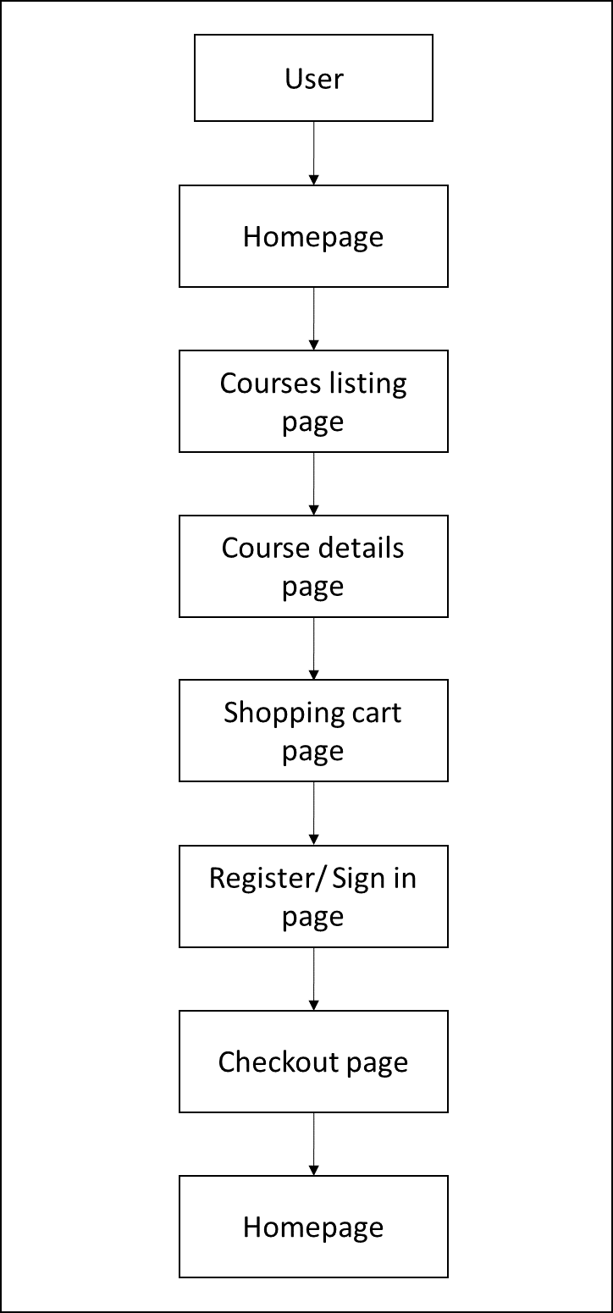

**Figure 3.5 Navigation Diagram of User**

**Figure 3.6** shows admin’s navigation diagram that begins with log in, dashboard and from there admin can choose the activity. The logout features is there on each of the web page.

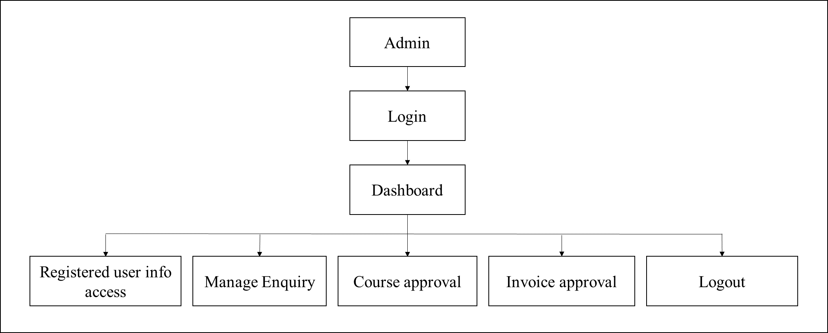

**Figure 3.6 Navigation Diagram of Admin**

**Figure 3.7** shows instructor’s navigation diagram which navigates from login page to dashboard and from there instructor can choose the activity. They are quite similar with the admin navigation diagram but with slightly different functions.

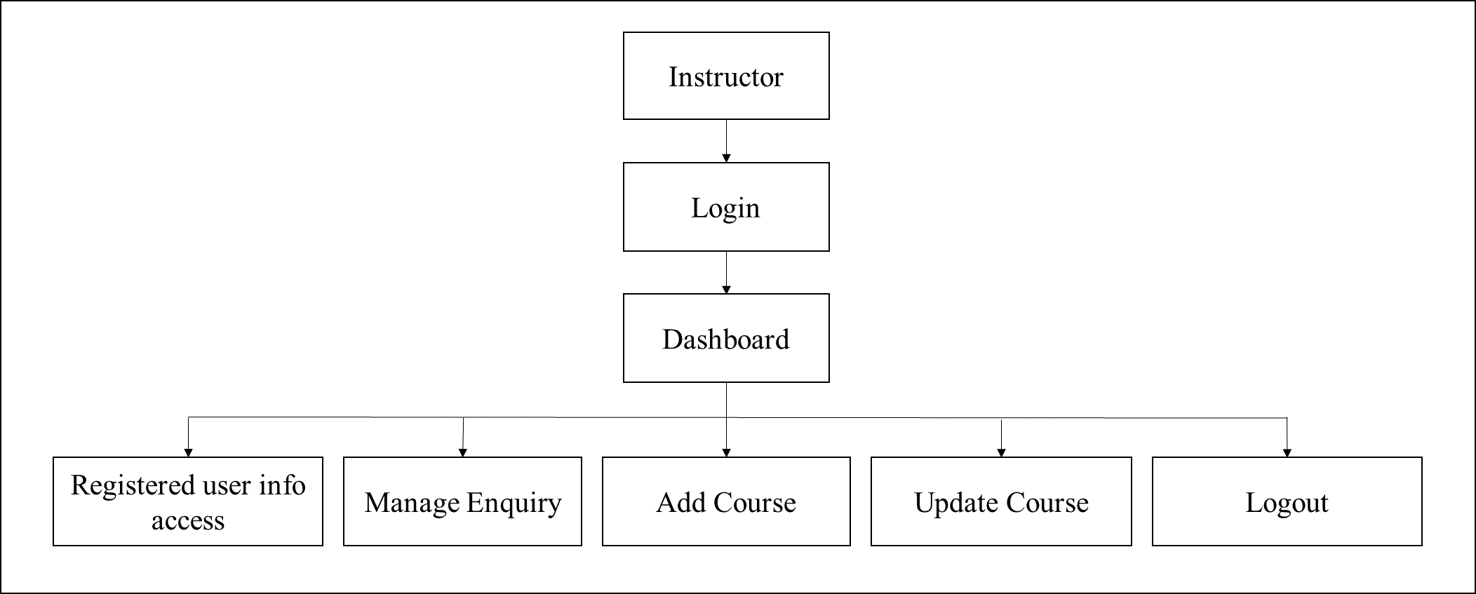

**Figure 3.7 Navigation Diagram of Instructor**

**3.7 SYSTEM INTERFACE LAYOUT**

**3.7.1 User’s Interface**

**Figure 3.8** shows the homepage of UNITEN Executive Education Programme Management System. The homepage contains information about the department and contact details for any kind of enquiry. It also provides subscription through email for any updates.



**Figure 3.8 Homepage**

**Figure 3.9** shows the enquiry form which can be found in the bottom of homepage.

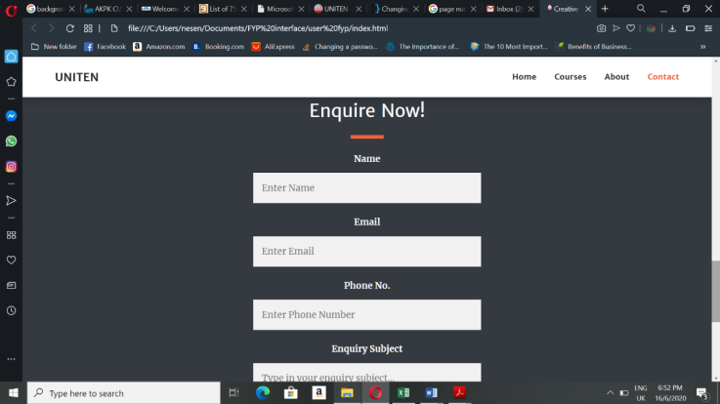

**Figure 3.9 Enquiry form**

**Figure 3.10** displays the list of courses provided by the department. Users can choose the categories they are interested in from the options given on the side or search for the courses with the search option. For further details of the programmes, details button should be clicked by the users.

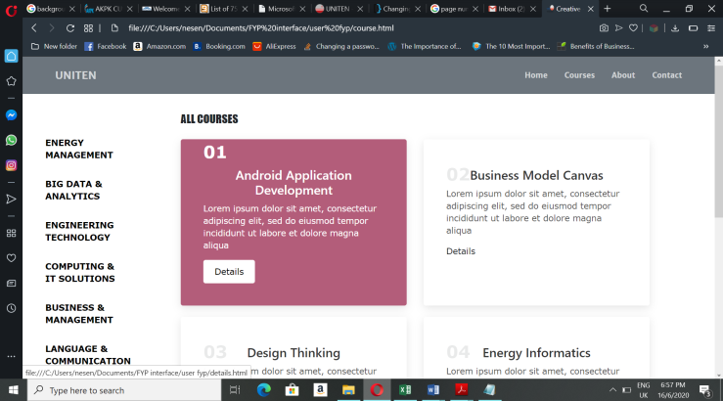

**Figure 3.10 Course List Page**

**Figure 3.11** shows the course descriptions after the details button clicked which is added by the admin. If users are interested in the course and want to purchase it they can click the “add to cart” button.

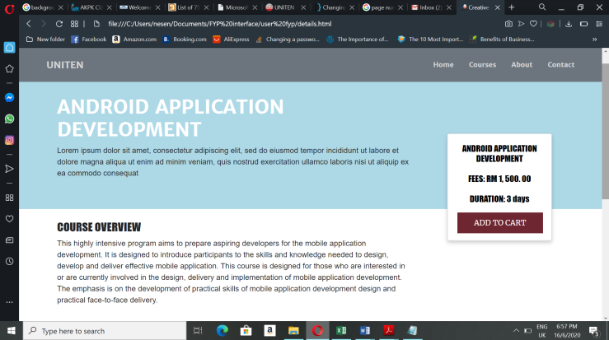

**Figure 3.11 Course Details Page**

After a course added to cart, the system will display the shopping cart page as in **Figure 3.12**. It has a table that contains course’s name users want to purchase with the quantity option and total amount of the course. If users want to confirm order, the “Proceed to Checkout” need to be clicked to continue the process.

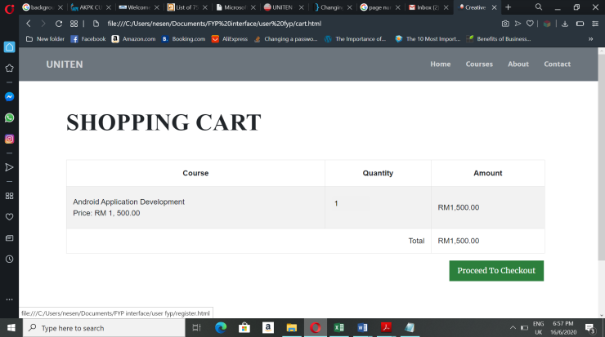

**Figure 3.12 Shopping Cart Page**

**Figure 3.13** shows a registration form where users have to fill up their name, email address, password, phone number, choose category whether they are a student or an employee to register. If users already registered before they have to sign in by clicking sign in.

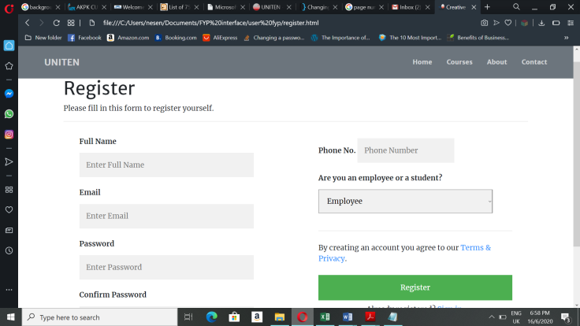

**Figure 3.13 User Register Page**

**Figure 3.14** shows the sign in page where users must enter their email address and password they used to register before to confirm order. This page is for users who have already registered before.

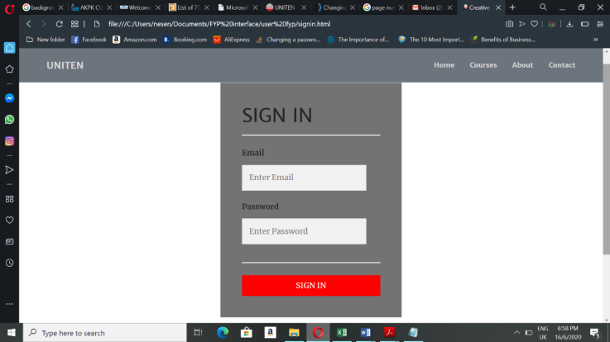

**Figure 3.14 User SignIn Page**

**Figure 3.15** shows the checkout page where payment details are entered by the users to pay for the order made. Users have to choose the payment method, full name, email address, billing address and click the done button to proceed with the payment. It will redirect users to online payment page according to the selection of payment method.

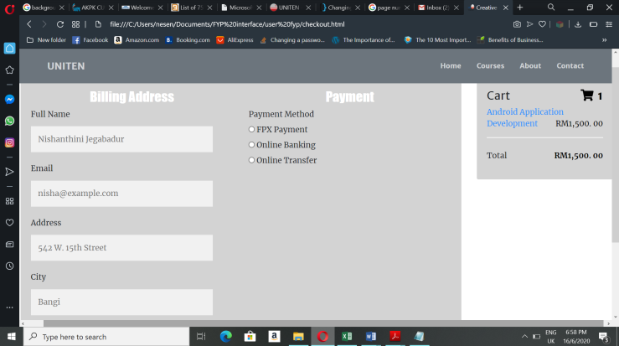

**Figure 3.15 Checkout Page**

**Figure 3.16** displays the payment successfully done and users will be notified with their invoice through email. This page will redirect to homepage upon clicking the ‘DONE’ button.

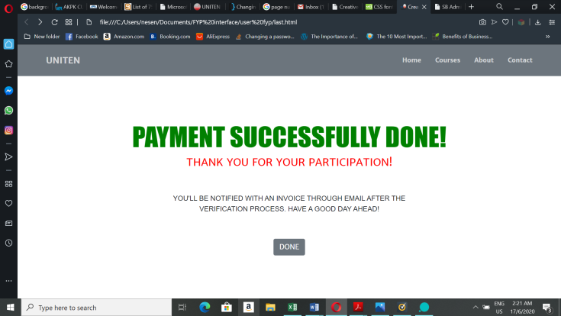

**Figure 3.16 Payment Successful Page**

**3.7.2 Admin’s Interface**

**Figure 3.17** shows the admin login page of UNITEN Executive Education Programme Management System. Admin can login into the system with Admin ID and password that specified for admins.

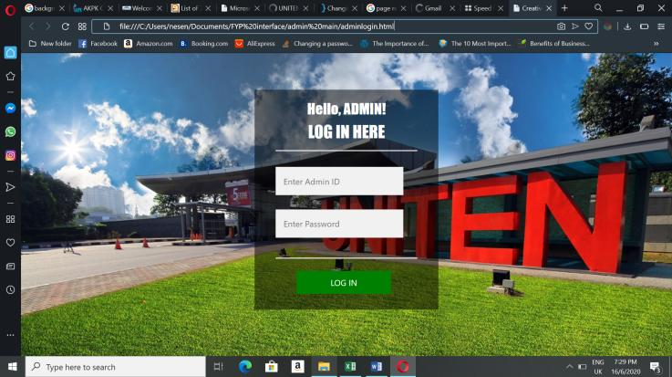

**Figure 3.17 Admin Login Page**

**Figure 3.18** shows the admin dashboard which displays all the key data in a webpage.

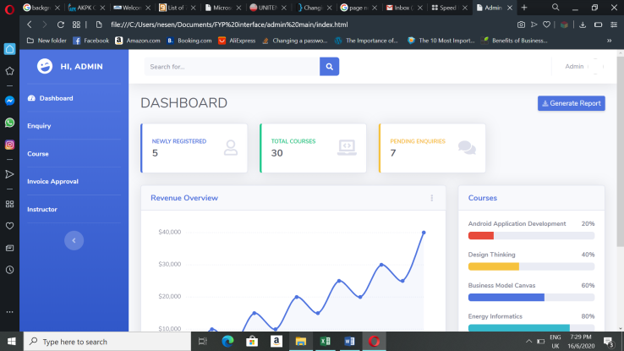

**Figure 3.18 Admin Dashboard**

**Figure 3.19** shows the enquiry management page where admins view the enquiries made by the users in table form and reply or decline each of the enquiry.

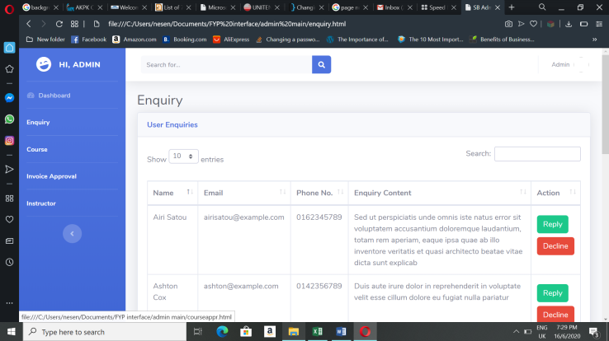

**Figure 3.19 Enquiry Management Page of Admin**

**Figure 3.20** shows course approval page where courses added by instructors shown in a table form. The admin will approve or decline the courses according to the requirements.

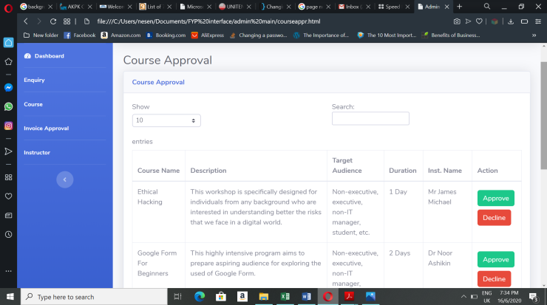

**Figure 3.20 Course Approval Page**

**Figure 3.21** shows invoice approval page where admin approves invoice for the payment made by the users. The invoice will be declined by the admin if they find any error in the payment made.

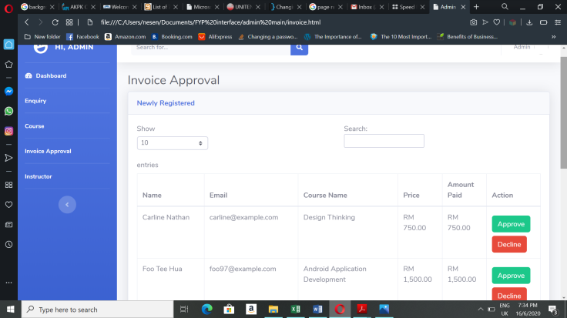

**Figure 3.21: Invoice Approval Page**

**Figure 3.22** displays instructors’ list who is involved in UNITEN Executive Education Programmes. Admin can add instructors by clicking the green button.

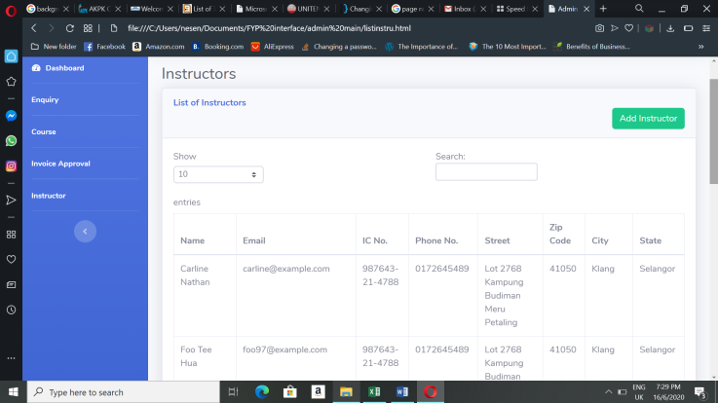

**Figure 3.22 Instructors’ List Page**

**Figure 3.23** shows the online form used by admin to create instructor account by adding their information such as their full name, email, phone number and others.

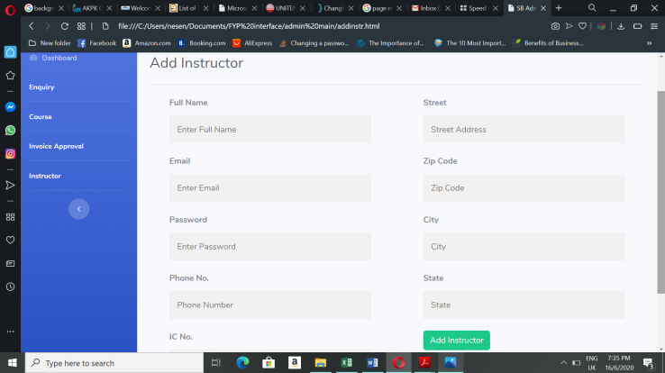

**Figure 3.23 Form to add instructors**

**Figure 3.24** shows a prompt where admin given a choice logout to end the current session. Logout option can be found at the top right of the page. Upon logging out, the page will be redirected to the admin login page.

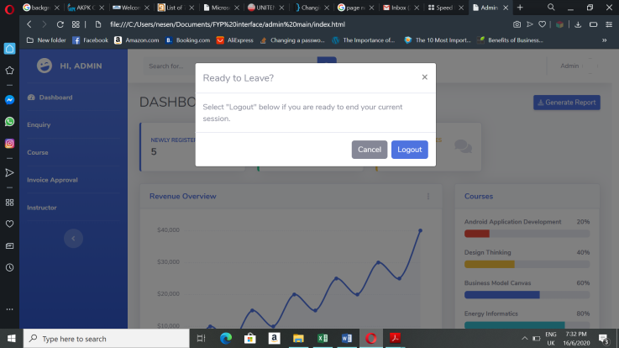

**Figure 3.24 Logout Prompt of Admin Page**

**3.7.3 Instructor’s Interface**

**Figure 3.25** shows the instructor login page where instructors can login into UNITEN Executive Education Programme Management System with their email address and password.

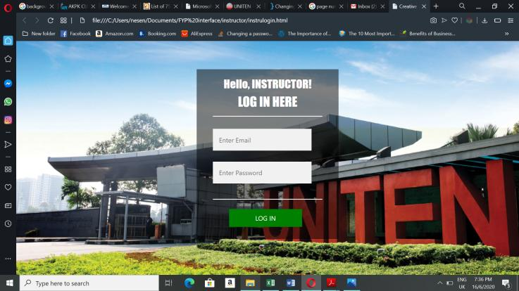

**Figure 3.25 Instructor Login Page**

**Figure 3.26** shows instructor dashboard which displays key data such newly registered, course current capacity and number of total courses in the system.

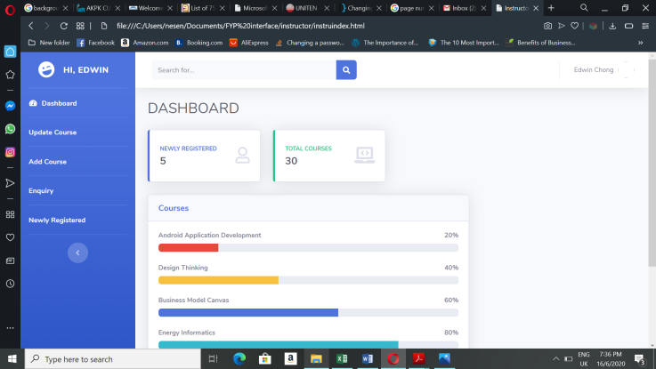

**Figure 3.26 Instructor Dashboard**

**Figure 3.27** shows the course list that are approved by the admin and instructor can view and edit the course contents.

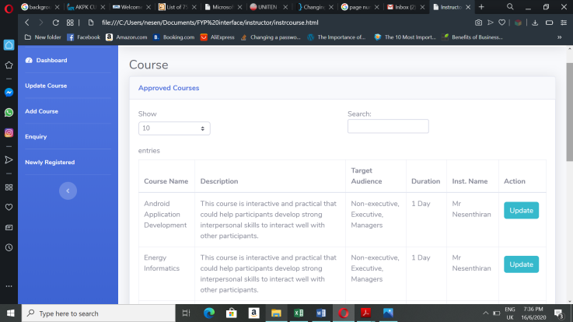

**Figure 3.27 Approved Course List Page**

**Figure 3.28** shows a form where instructors can edit the content of the course and update it.

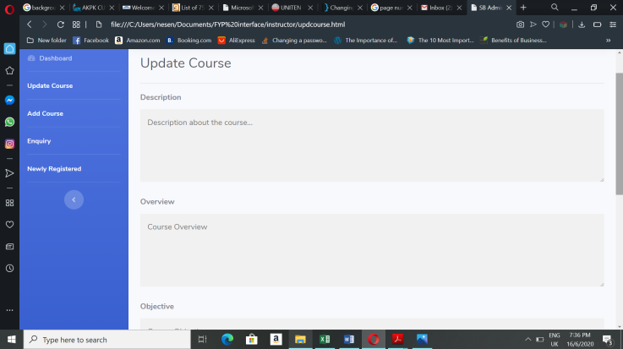

**Figure 3.28 Update Course Form**

**Figure 3.29** shows a form that used by instructors to add course which will approved by the admin later. This form requires the course name, description and more course details.

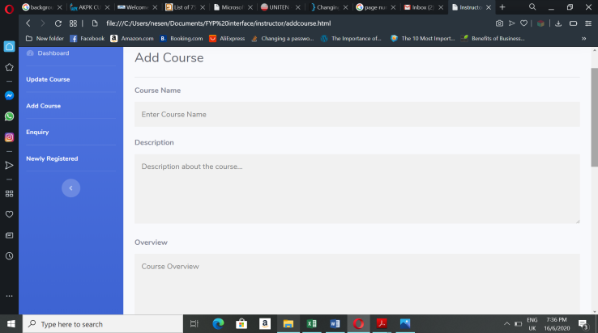

**Figure 3.29 Add Course Form**

**Figure 3.30** shows the enquiry management page where instructors can view the enquiries made by the users in table form and reply or decline each of the enquiry.

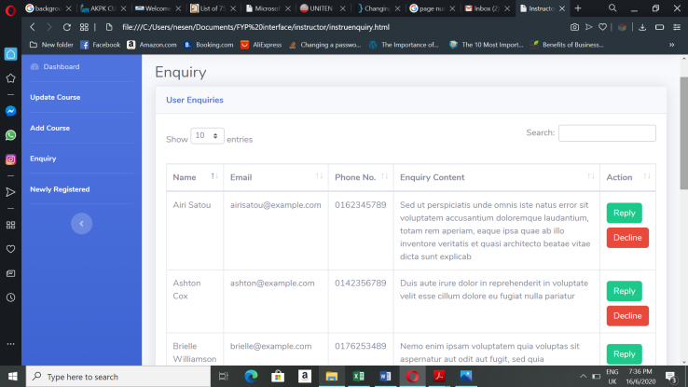

**Figure 3.30 Enquiry Management Page of Instructor**

**Figure 3.31** shows the information of users who recently registered courses and instructors have access to view it.

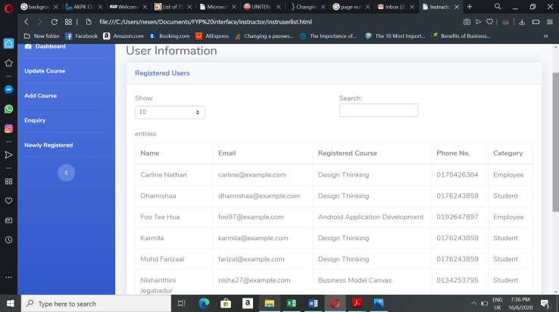

**Figure 3.31 Users’ Information Page**

**Figure 3.32** shows a prompt where instructors given a choice logout to end the current session. Logout option can be found at the top right of the page. Upon logging out, the page will be redirected to the instructor login page.

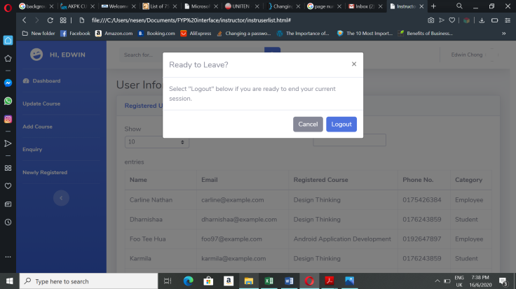

**Figure 3.32 Logout Prompt of Instructor Page**

**3.8 CONCLUSION**

This chapter mostly discussed about the design part of the project which can be used as a guideline to develop the complete system that includes coding and testing. This will make the construction phase easier later in the Project 2. This chapter also includes the diagrams and data dictionary which can be helpful in organizing the database structure.

**CHAPTER 4**

**IMPLEMENTATION**

**4.0 Overview**

Chapter 4 focuses on developing the proposed system and implementing the designs shown in the last chapter. Hardware and software used to

**4.1 Development Environment**

Development environment is essential for developing any software or application because it provides suitable hardware and software that a system developer needed to build systems. This environment helps to speed up the development process and also reduce the number errors made by the developers from time to time by giving a clear picture to them. Without development environment, developers would not be able to complete projects on time.

**4.1.1 Hardware Requirements**

The main component used to develop the ‘UNITEN Executive Education Programme Management System’ is a laptop. **Table 4.1** shows the hardware specifications of the laptop that has been used for system implementation.

**Table 4.1:** Hardware Requirements

|  |  |
| --- | --- |
| **Hardware** | **Description** |
| Processor | Intel CoreTM i5 |
| RAM | 4GB |
| Storage available | 42.1GB |

**4.1.2 Software Requirements**

**Table 4.2** shows the list of software and tools required to develop the UNITEN Executive Education Programme Management System (EEProMS).

**Table 4.2:** Software Requirements

|  |  |
| --- | --- |
| **Software** | **Description** |
| Opera & Microsoft Edge | These web browsers used to run the code |
| XAMPP Server | Server used to host the developed system |
| Notepad++ | To write and edit source code |
| PhpMyAdmin | Database that gives connection to the system created in phpMyAdmin |

**4.2 Implementation of UNITEN EEProMS**

UNITEN Executive Education Programme Management System used ‘Waterfall Model’ approach where implementation phase of the system began only after design phase is completed. For this system, the interface design in Chapter 3 re-used for the implementation phase after making some changes as it was developed using HTML and CSS code. After that, several tables are created in phpMyAdmin which are listed in the previous chapter as data dictionary. Later, to establish the connection between the system interface and database, PHP language code used by the developer to make the system functional.

**4.2.1 Description of Developed System**

This system is mainly developed for UNITEN Business Development Department to manage the courses or programs they provide. This system helps the admin, instructor and users to connect with each other in maintaining and managing the educational programs.

**4.3 Technical Detail of Implementation**

Different types of tools and software such as Notepad++, phpMyAdmin and GitHub has been used in order to complete the implementation phase of the proposed system.

**4.3.1 Notepad++**

Notepad++ is easy to get as it can be installed from browser for free. And it is also easy to use as the code organized well and the error made by developers can be identified quickly. Figure 4.1 shows the code written in Notepad++.

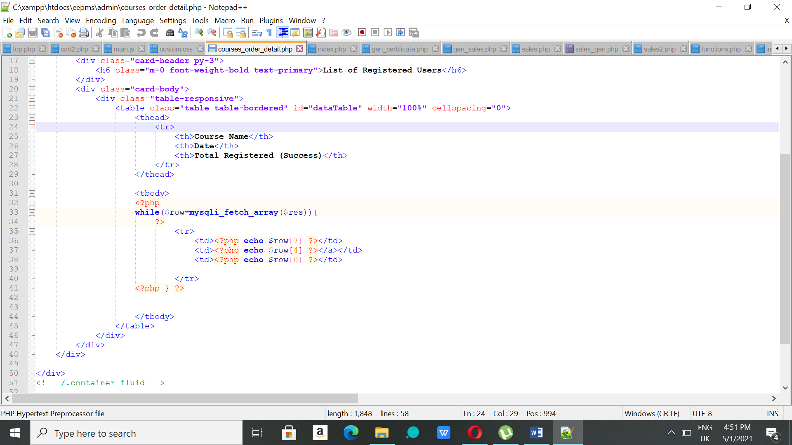

**Figure 4.1:** Code in Notepad++

**4.3.2 PhpMyAdmin**

PhpMyAdmin is used to create database where data can be stored, retrieved, updated, deleted and more. It holds data inserted throughout the use of system. **Figure 4.2** shows the list of tables created for this system.

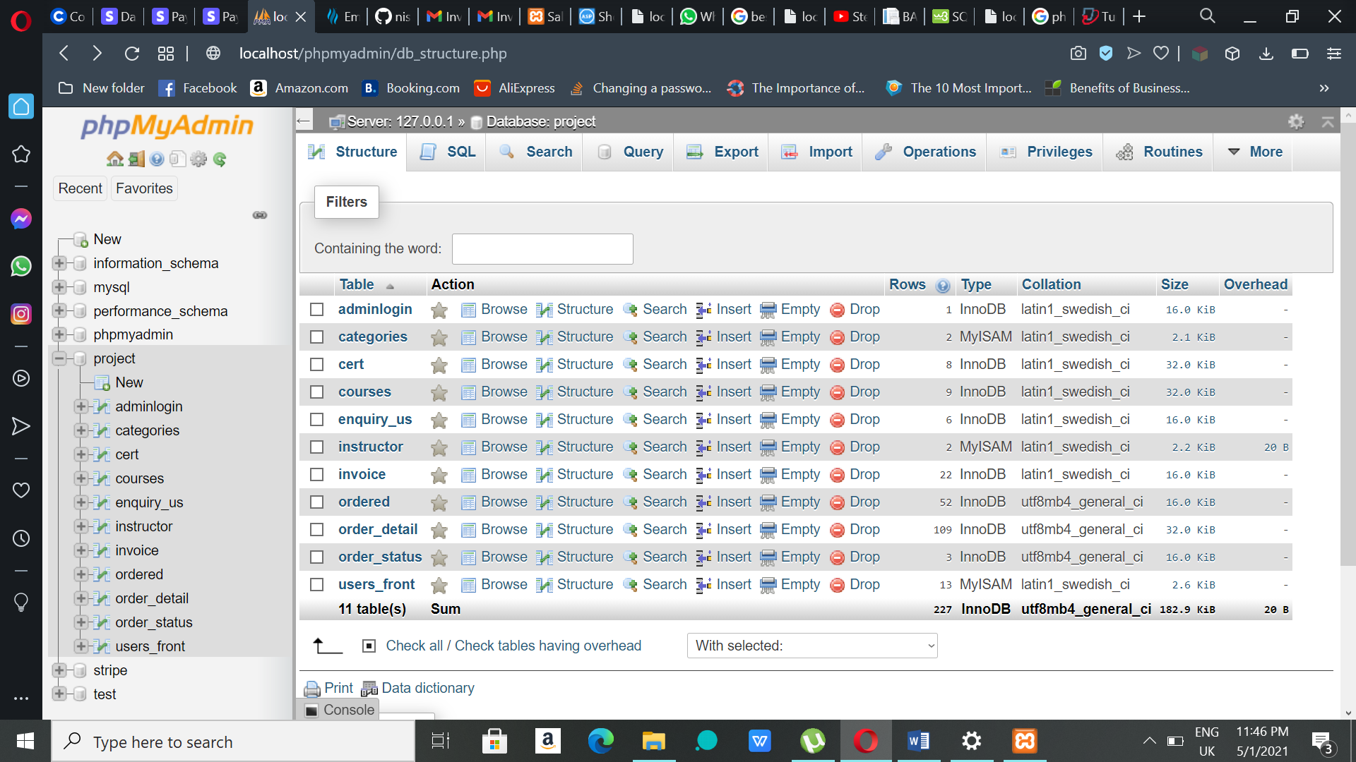

**Figure 4.2:** phpMyAdmin

**4.3.3 GitHub**

GitHub was used to store the project folder safely and acts as a backup where the folder can inserted and updated easily. It is also used by the developer to get reference code that can referred to write the code. Figure 4.3 shows the project folder stored in the GitHub.

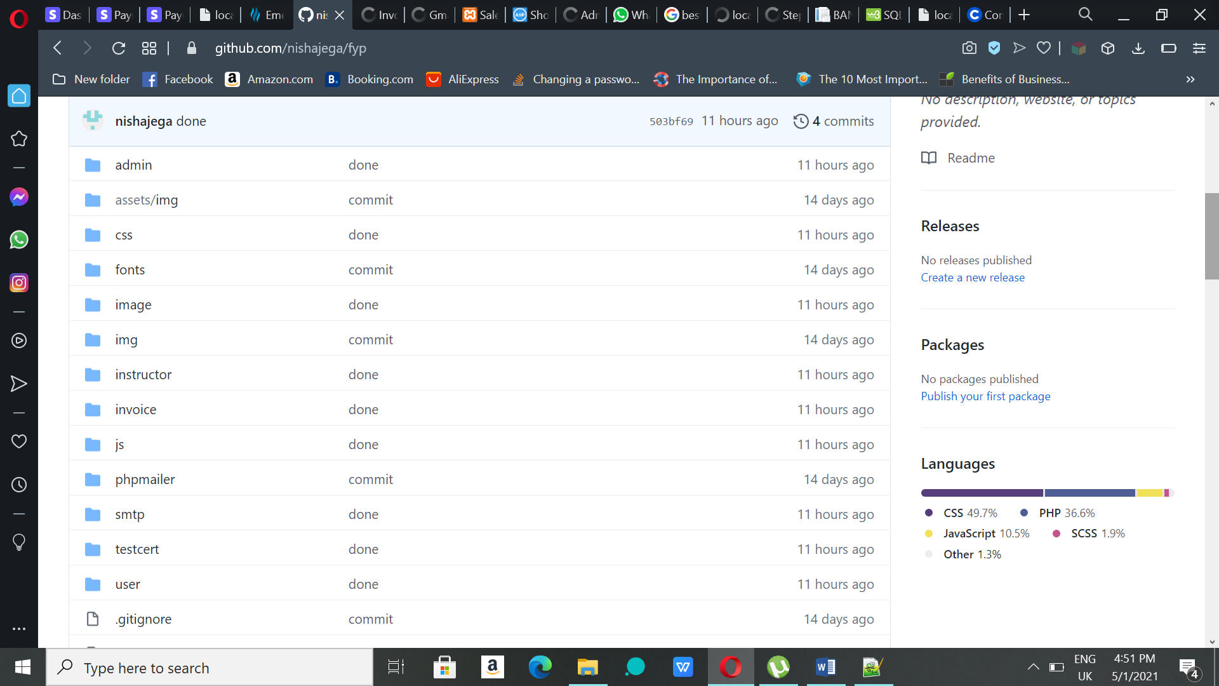

**Figure 4.3:** GitHub

**4.4 DATABASE IMPLEMENTATION**

There are 10 tables under the ‘project’ database that has been used by the developer. Below are the list of tables with their structure.

**Figure 4.4** shows the admin login table that has two attributes named username and password and this table has administrator’s login details.

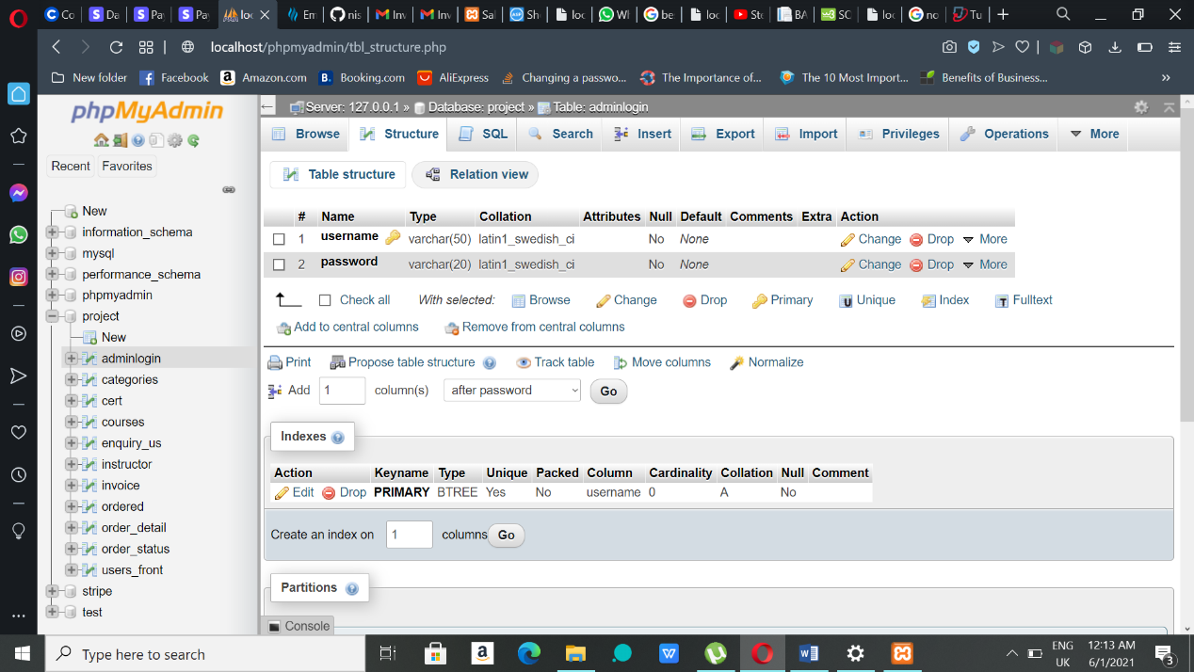

**Figure 4.4:** Admin login table

**Figure 4.5** shows the categories table that has three attributes names id (unique), categories and status and this table stores course’s category details.

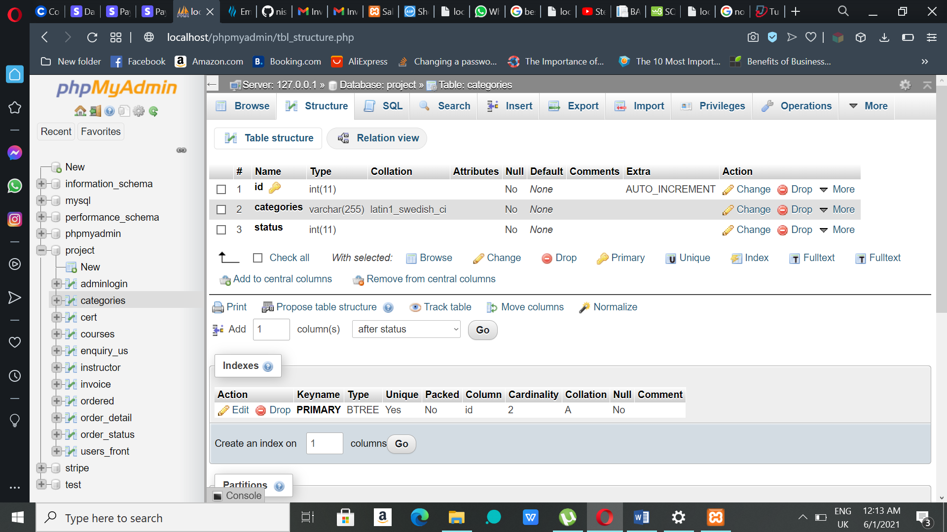

**Figure 4.5:** Categories table

**Figure 4.6** shows certificate table that contains attributes such as id, order detail id, name, email, course, date, instructor and status. This table stores data that will be used for e-certification.

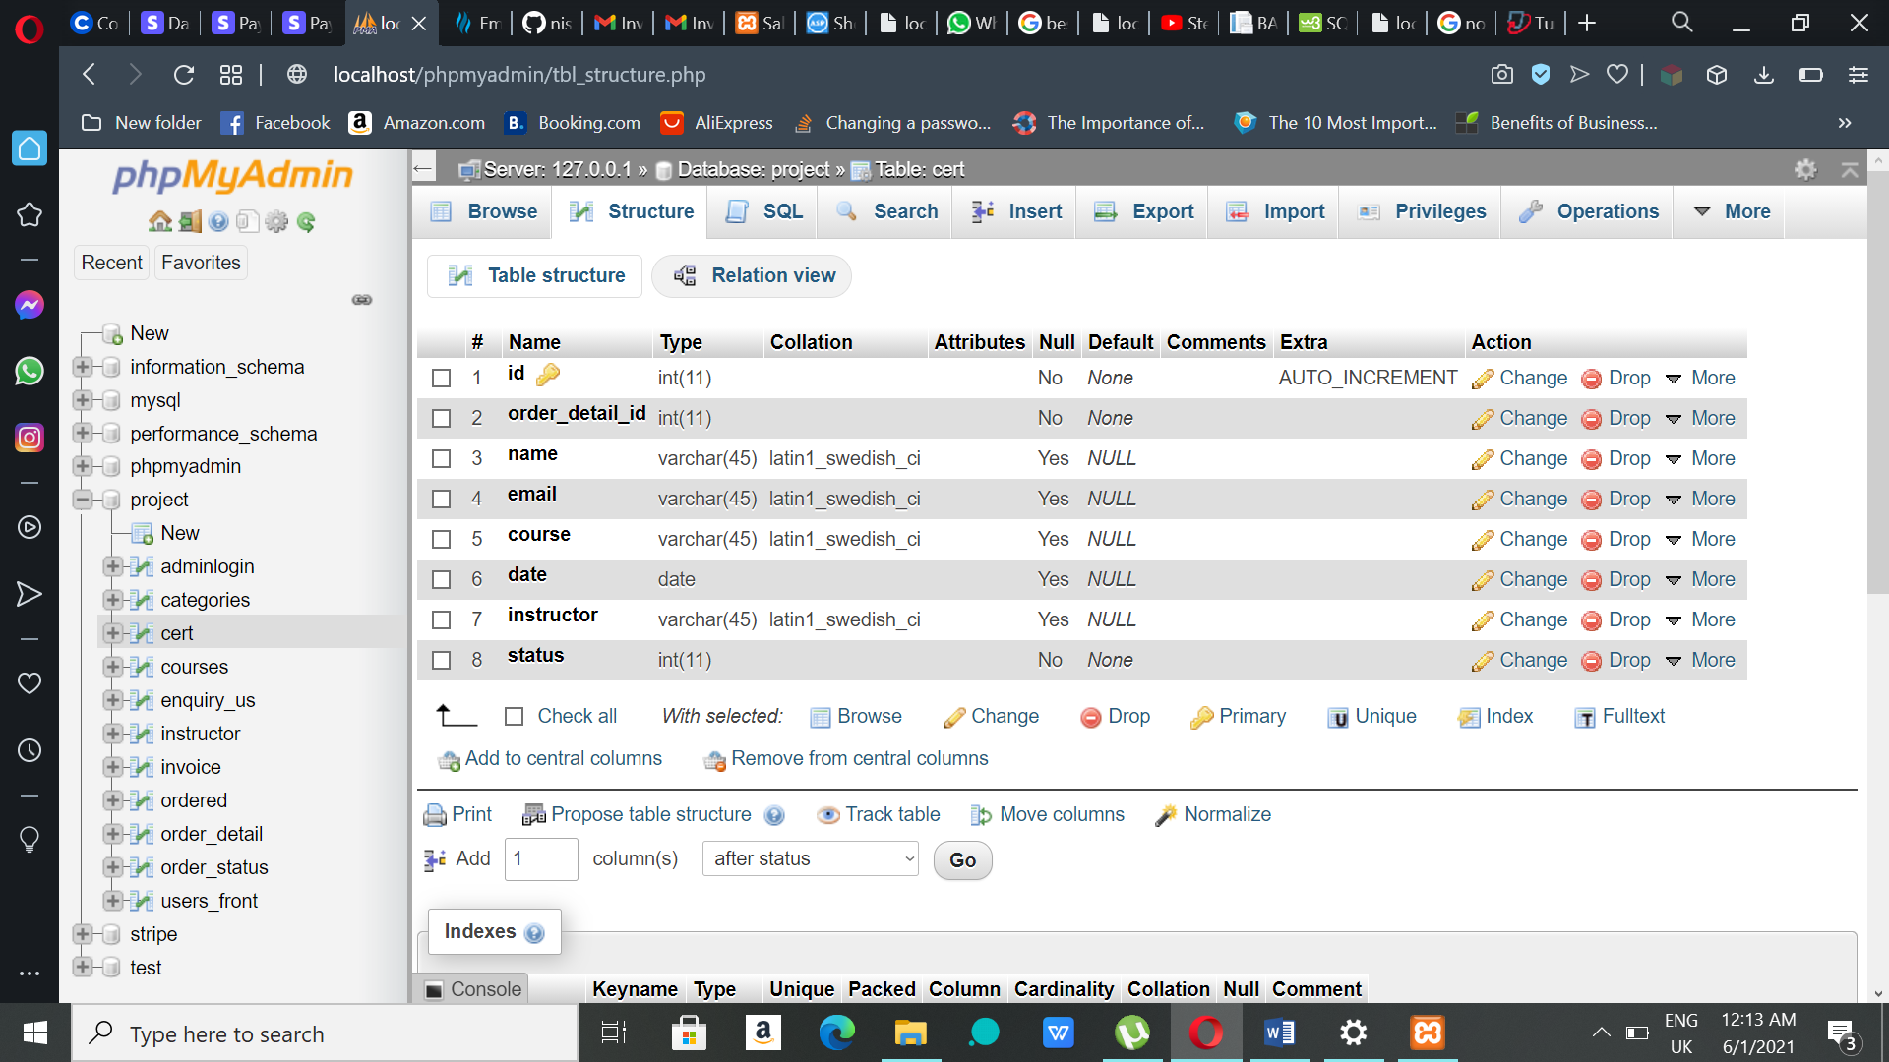

**Figure 4.6:** Certificate table

**Figure 4.7** shows the courses tables which contains many attributes such as id, categories id, name, description, overview, audience target, duration, price, date, date2, date3, date4, instructor name, active and filename. This table is used to store course or program details.

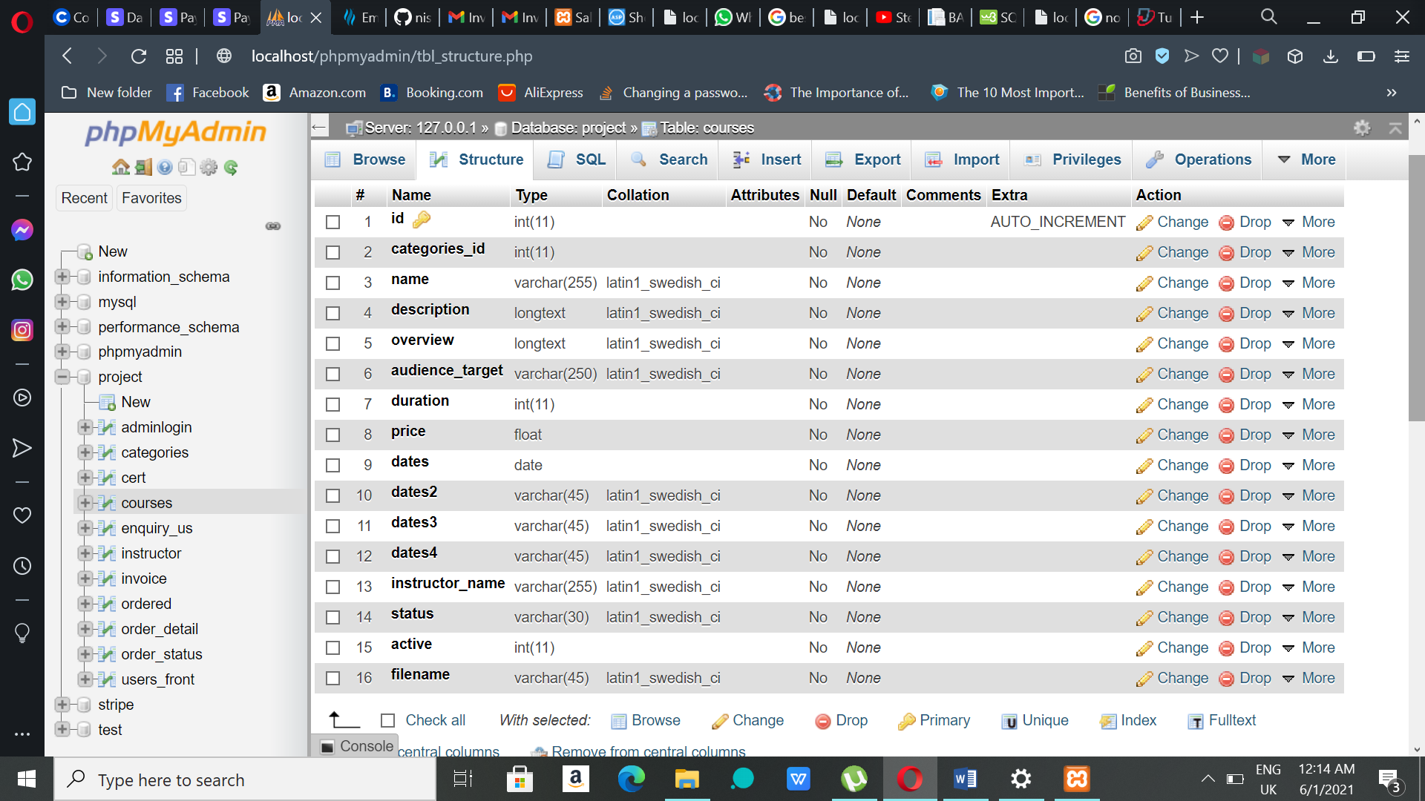

**Figure 4.7:** Courses table

**Figure 4.8** shows the enquiry table which contains attributes such as id, name, email, phone and enquiry. This table has details of enquiry made by the users.

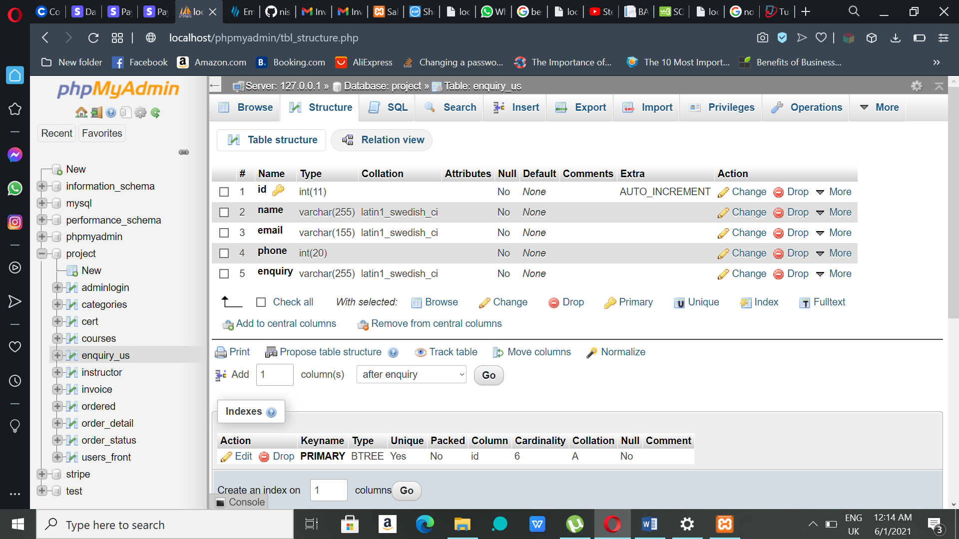

**Figure 4.8:** Enquiry table

**Figure 4.9** shows instructor table that contain id, name, email, password, staff number, verification id, verification status and status as attributes. This table has data of registered instructors.

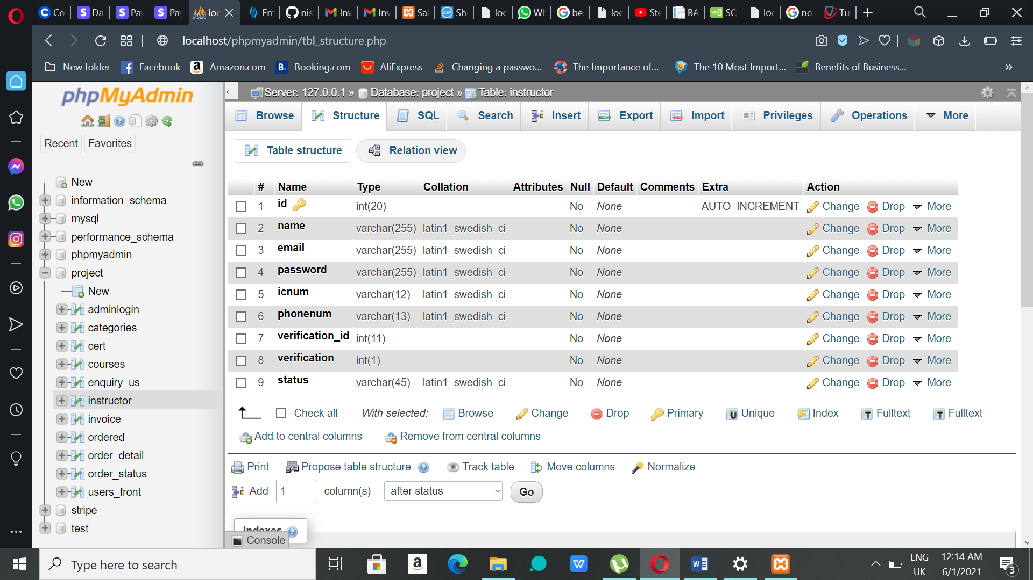

**Figure 4.9:** Instructor table

**Figure 4.10** shows the order table which contains attributes such as id, user name, address, state, postcode, total price, payment status, token, order status and added on. The data after making purchases will be inserted in this table.

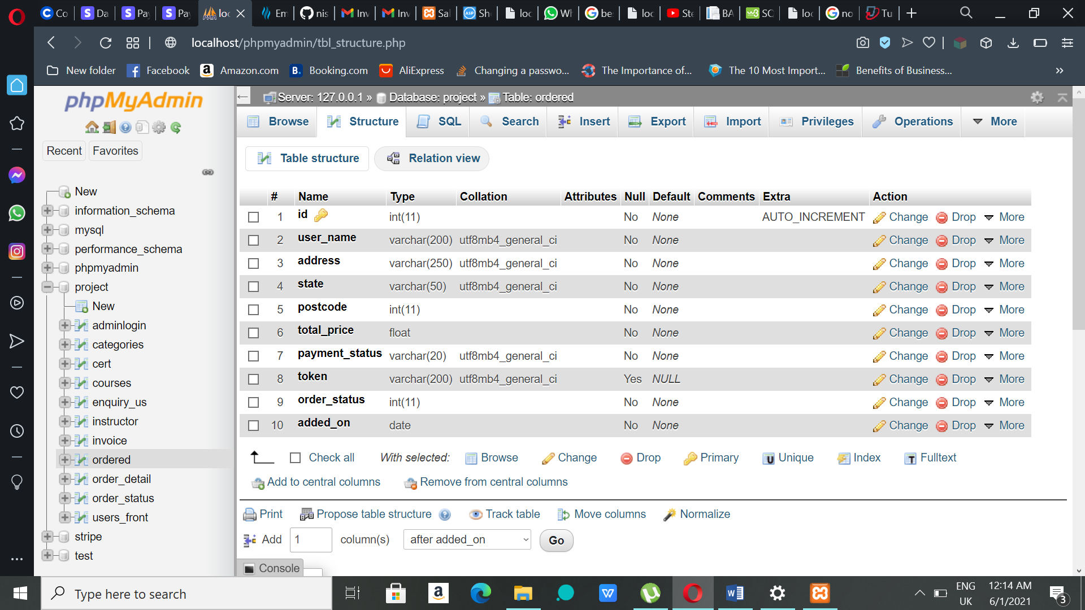

**Figure 4.10:** Order table

**Figure 4.11** shows order detail table that has id, ordered, product id, date, quantity and price as attributes. This table contains order details of every order.

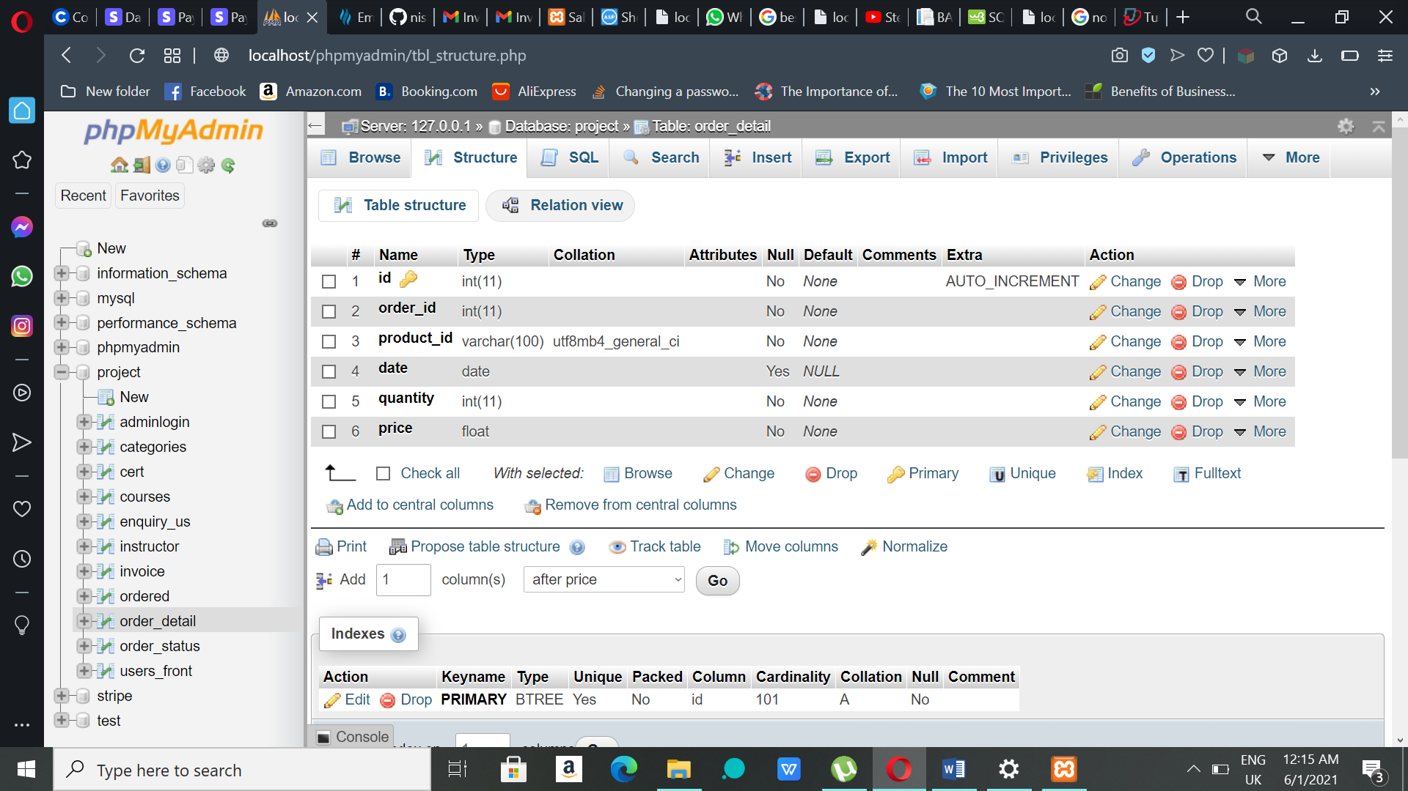

**Figure 4.11:** Order detail table

**Figure 4.12** shows order status table that has only two attributes named as id and name. This table contains data of order status.

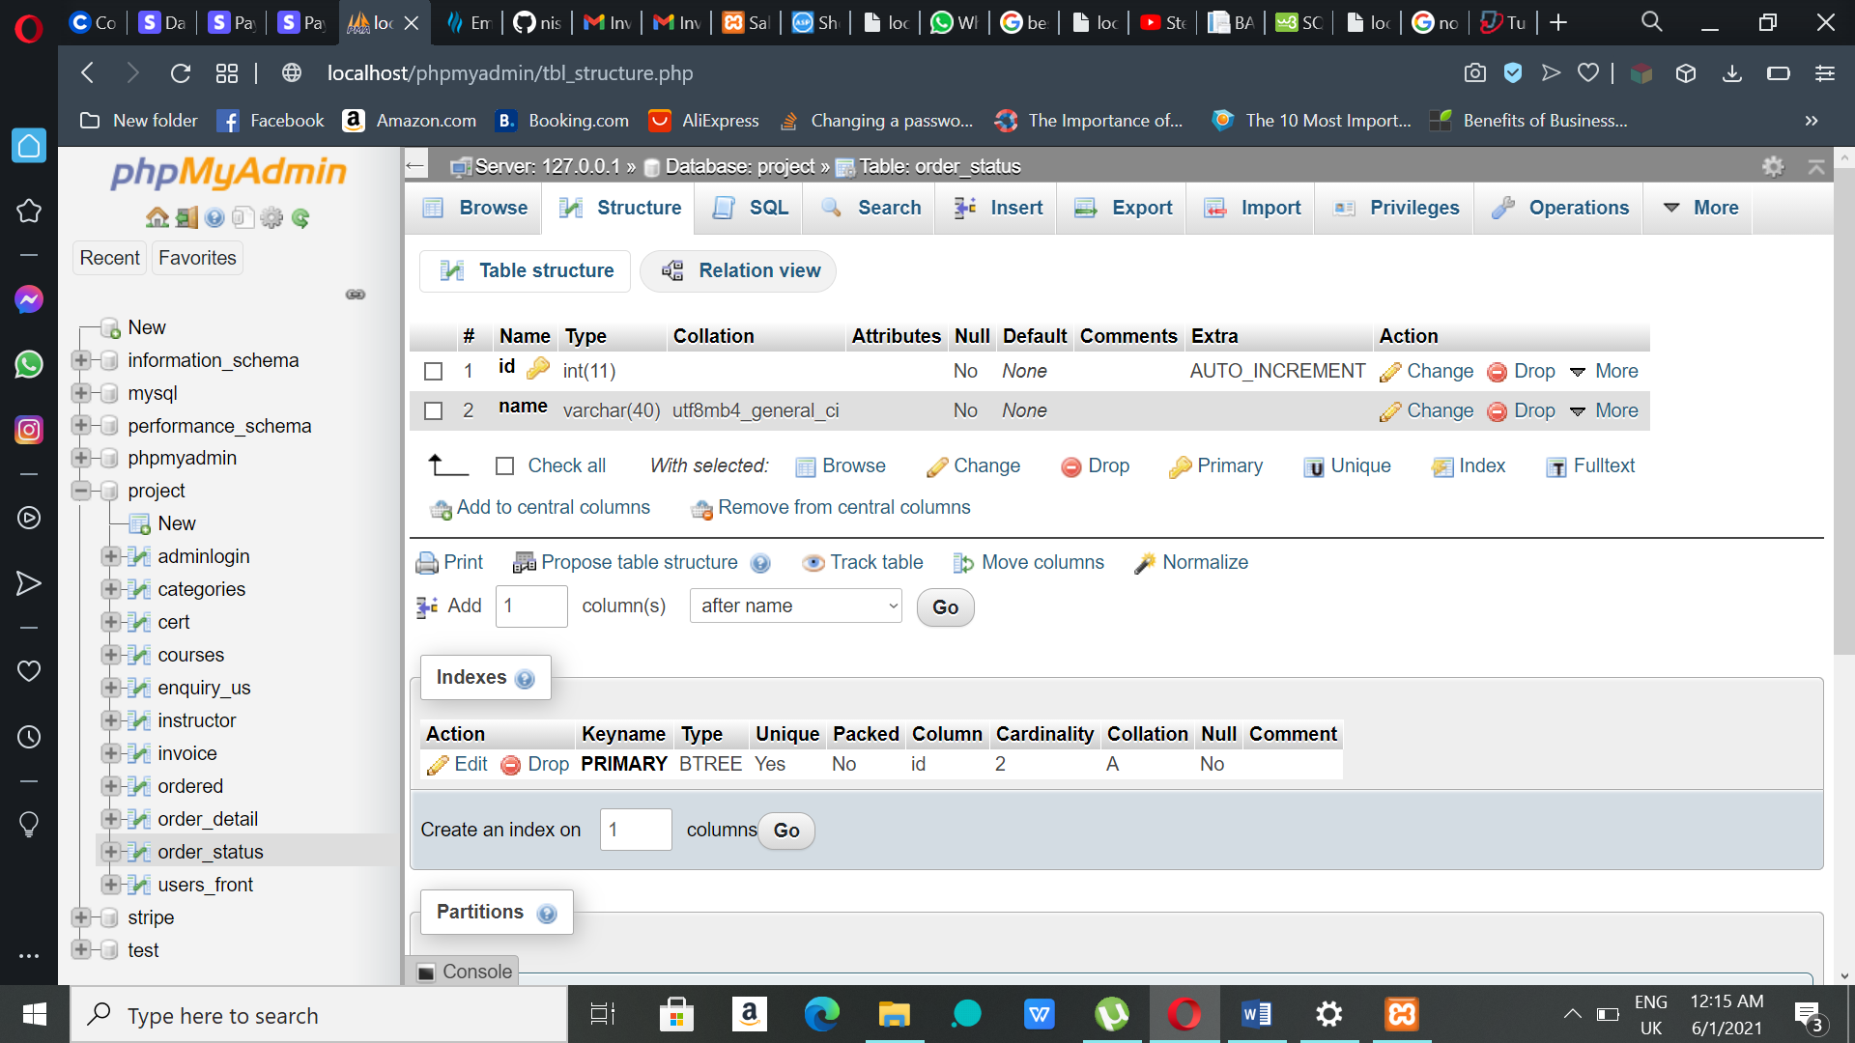

**Figure 4.12:** Order status table

**Figure 4.13** shows users table that contains id, name, email, password and phone number as attributes. This table has the users’ information who registers in the system.

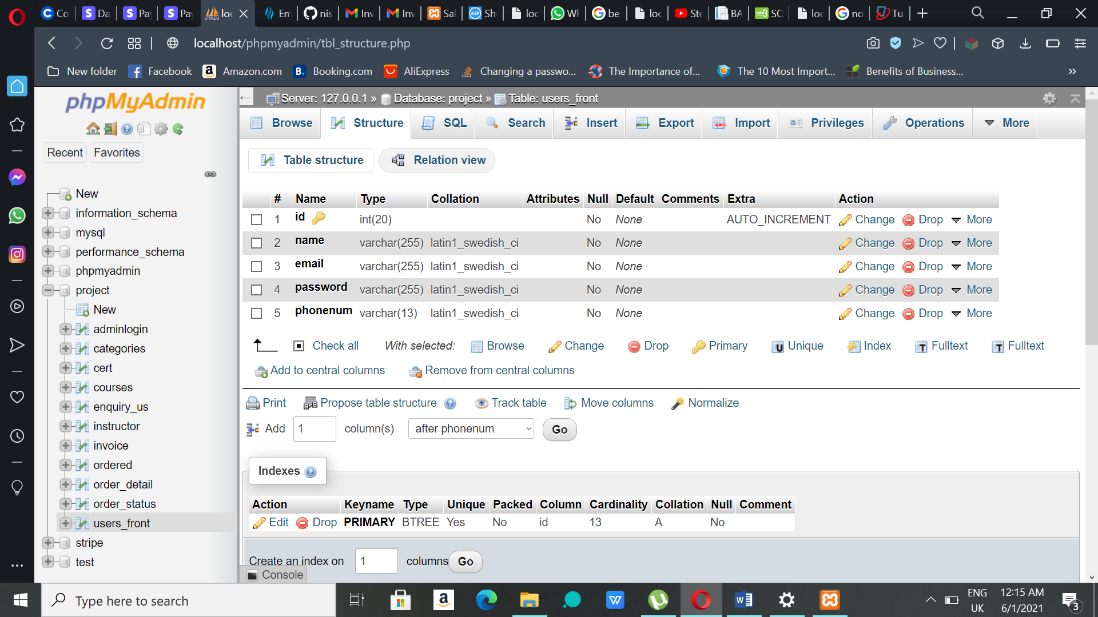

**Figure 4.13:** User table

**4.5 USER MANUAL**

**4.0 CONCLUSION**

**4.1 Introduction**

In conclusion of Project 1, this documentation described about the design and implementation of the proposed project which is UNITEN Executive Education Programme Management System. This project is mainly about managing the courses and users of executive education programmes provided by BDD of UNITEN. Manual way of managing this courses is problematic and time consuming which is why having an all-in-one system that can manage the courses would make the whole process easier. There are many similar systems available as discussed earlier but this system is specially designed for BDD of UNITEN with its own functionalities to reduce the hassle between the users and the management.

**4.2 Outcome of Project 1**

There are three main phases that are considered to be outcome of Project 1. Introduction is the first phase where UNITEN Executive Education Programme Management System proposed and introduced by stating the problem and the background of it. The objectives and the scope of the system also identified in this phase. In the second phase, analysis takes place where existing similar system are analysed and this helps to decide the functionalities for the proposed system. Waterfall Model was chosen as the most suitable software development methodology which helps in developing the system. Besides, interview was conducted to gather the requirements of the proposed system. Finally comes the design phase where interfaces of the proposed system and tables required for the database are designed. Despite the fact that the interfaces designed for this project may be different from the final product which is Project 2, but it gives us an image on how the proposed system will look like. These three phases will guide and help us through the Project 2.

**4.3 Problems Encountered**

There are some problems encountered during the development of Project 1. First of all, when online learning was introduced it was hard to adapt the method in the first place because doing the whole project away from the university was totally unexpected. Due to this, the interviews, surveys and researches are conducted through online which was new for all. Other than that, finishing up and submitting each of the milestone before the deadline was one of the problem encountered because other subjects’ tasks were also need to be done on time. Hence, the workload was high which causes insufficient time to complete the tasks or project on time.

**4.4 Limitations**

There are some limitations identified for this project. First of all, due to this project is a web-based system it requires internet connection to access to the website. If the device not able to connect to internet or the internet goes down in any situation, user will not be able to access the system. Besides, there are so many versions for a browser and all the users are not using the same version. This system may not be supported across all version of browser. Lastly, internet speed is also one of the limitations for this proposed system. Especially, reduce in the speed of the internet during the registration and payment process may cause problem for the users; internet speed must be strong for efficient use of the system.

**4.5 Planning for Project 2**

Before starting with Project 2 for next semester, there some things planned beforehand. One of it is finishing the project within the timeframe so that there will no need for rushing in the last minute. If the project was done within the timeframe then, extra functions can be added to make it whole lot preferable. Not just that, Project 2 must fulfil all the criteria it requires and functions properly to make the project one of the best. There are some betterment need to be done with the design of interfaces so that it attracts more users. UNITEN Executive Education Programme Management System will be useful for the users when it is executable in future.

**REFERENCES**

[1] *Waterfall Model*. Retrieved from: <https://www.coursehero.com/file/53252184/Waterfall-modeldocx/>

[2] *UNITEN Professional Services*. Retrieved from: <https://www.uniten.edu.my/business-plus-service/professional-services/>

[3] Wikipedia. *Introduction to Software Engineering/Process/Methodology.* Retrieved from: [https://en.wikibooks.org/wiki/Introduction_to_Software_Engineering/Process/Methodology#](https://en.wikibooks.org/wiki/Introduction_to_Software_Engineering/Process/Methodology)

[4] Wikipedia. *Waterfall Model*. Retrieved from: <https://en.wikipedia.org/wiki/Waterfall_model>

**TURNITIN REPORT**

